**System Hacking**

**Index:**

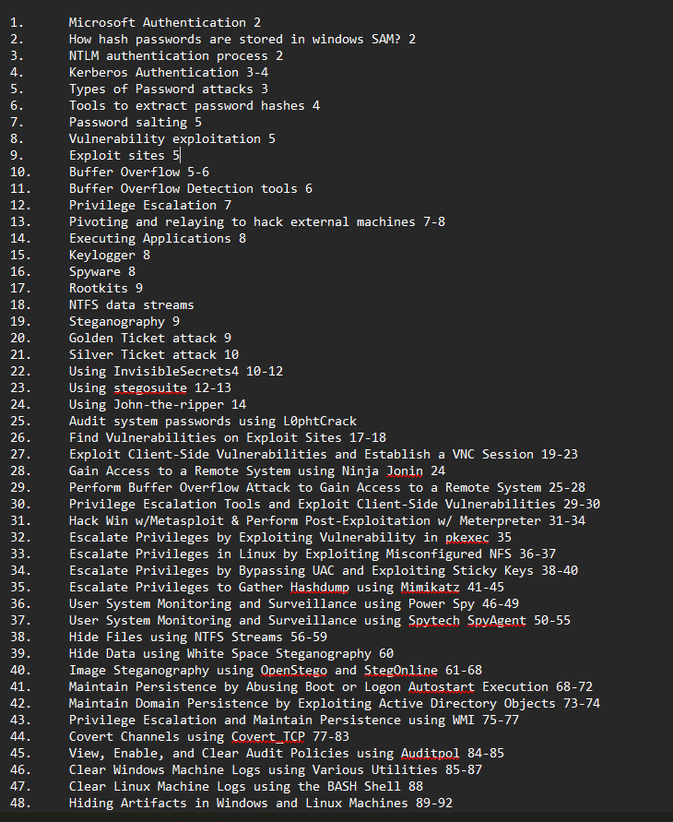

**Microsoft Authentication:**A system used for verifying users on Windows networks, using several mechanisms to store credentials and enable secure access.

1. **SAM Database**:  
   Stores hashed passwords locally on standalone systems and non-domain-joined machines, used by the Windows Security Accounts Manager for authentication.
2. **NTLM Database**:  
   Holds credentials for NT LAN Manager (NTLM), a legacy protocol for Windows networks that uses challenge-response mechanisms to authenticate without sending plain-text passwords.
3. **Kerberos Database**:  
   Stores credentials for Kerberos, a network authentication protocol that issues time-based tickets for secure access within Active Directory (AD) domains.

**How hash passwords are stored in windows SAM?**

Windows SAM stores hashed passwords using the **LM** and **NT hashes**. The NT hash is derived using the MD4 hashing algorithm, while the weaker LM hash (for backward compatibility) is often disabled. Both hashes are stored in the encrypted SAM database.

**NTLM Authentication Process:**

The NTLM authentication process involves a **challenge-response mechanism**. The server sends a random challenge to the client, which responds with an encrypted value using the NTLM hash of the user’s password. The server verifies it against the stored hash for authentication.

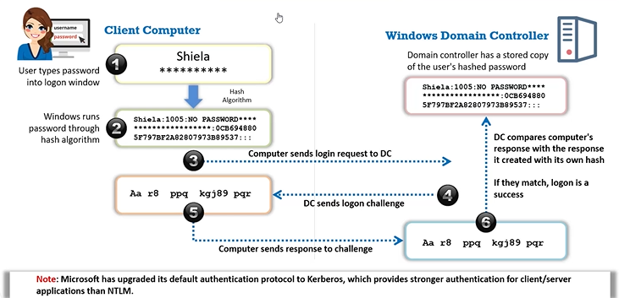

NTLM authentication can be bypassed using several attack techniques:

1. **Pass-the-Hash (PtH)**: An attacker captures and reuses the hashed password (NT hash) without needing the plaintext password.
2. **Relay Attack**: The NTLM authentication token is intercepted and relayed to another service for unauthorized access.
3. **Credential Dumping**: Tools like Mimikatz extract NTLM hashes from memory or the SAM database.
4. **Brute Force/Cracking**: Weak passwords can be cracked by brute-forcing the NTLM hash.
5. **LLMNR/NBT-NS Poisoning**: Man-in-the-middle attacks trick devices into sending credentials to the attacker.

**Kerberos Authentication:**

Kerberos uses time-based tickets issued by a trusted Key Distribution Center (KDC) to authenticate users securely, ensuring mutual authentication between clients and services without transmitting passwords.

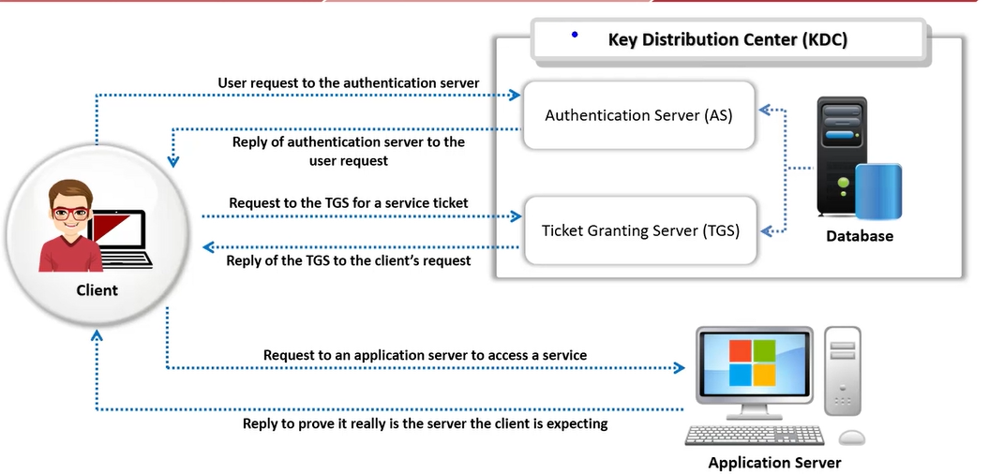

How this differ from NTLM?

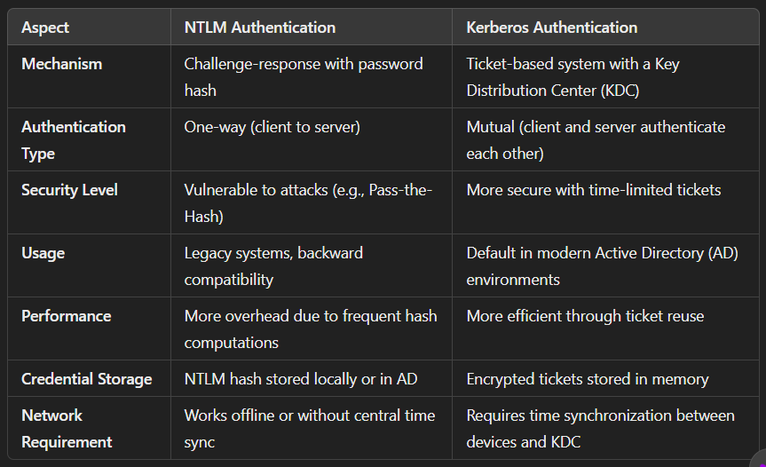

**Types of Password Attacks:**

1. **Non-electronic attacks**:  
   Use social engineering techniques, such as phishing or shoulder surfing, to trick users into revealing passwords (e.g., asking for login details via phone).
2. **Active online attacks**:  
   Involve real-time interaction with the target system, like **brute force** or **credential stuffing** on a login portal to gain unauthorized access.
3. **Passive online attacks**:  
   Monitor network traffic to intercept credentials without interacting directly (e.g., **packet sniffing** to capture plaintext passwords).
4. **Offline attacks**:  
   Involve cracking passwords by obtaining hashed credentials (e.g., using **hashes from the SAM database** and tools like Hashcat).

**Tools to Extract the Password Hashes:**

1. Pwdump7
2. Rainbowcrack
3. John the Ripper
4. Hashcat
5. THC-Hydra
6. Medusa
7. Secure Shell BruteForcer

**Password Salting:**

Password salting involves adding a random string of characters (salt) to passwords before hashing them. This enhances security by preventing identical passwords from producing the same hash, making it harder for attackers to use precomputed tables (rainbow tables) for cracking. It adds an extra layer of protection to user data.

**Vulnerability exploitation:**

It involves the execution of multiple complex, interrelated steps to gain access to a remote system.

**Exploit sites:**

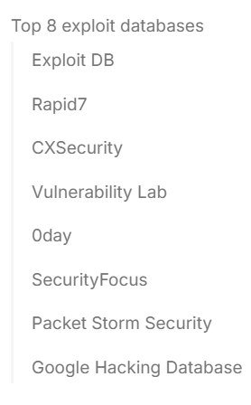

**Buffer overflow:**

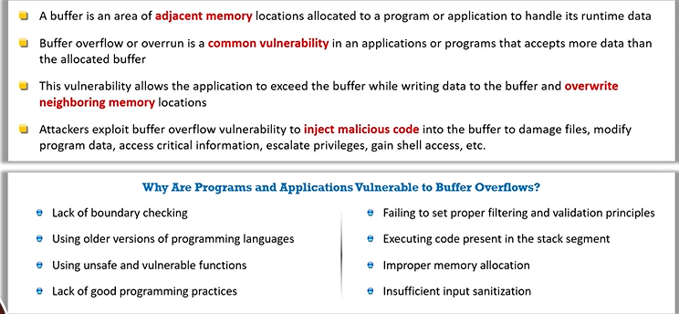

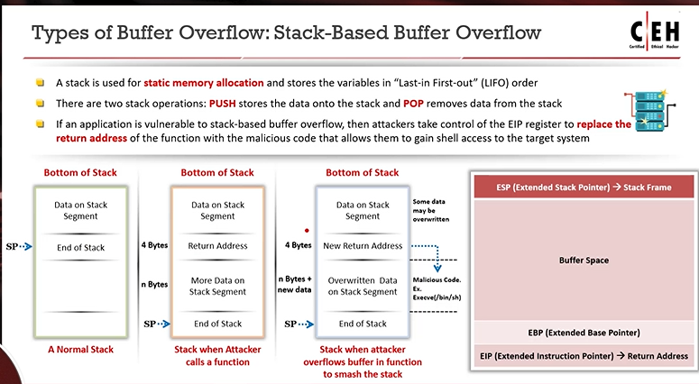

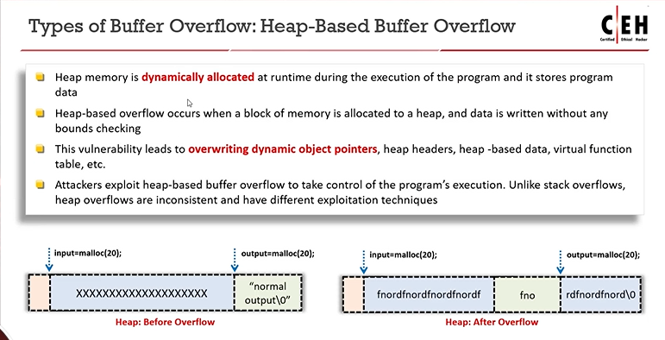

**Buffer Overflow Detection tools:**

* 1. Ollydbg
  2. Veracode
  3. Flawfinder
  4. Kiuwan
  5. Splint
  6. BOVSTT

**Privilege Escalation:**

It is a security exploit where an attacker gains elevated access to resources or data beyond their initial permissions. This can occur through vulnerabilities in software, misconfigurations, or user error, allowing the attacker to perform unauthorized actions, compromise systems, and access sensitive information.

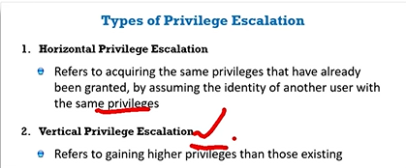

This escalation can be achieved by:

1. DLL hijacking
2. Exploiting Vulnerabilities
3. Dylib hijacking
4. Misconfigured NFS
5. Bypassing User account control

**Pivoting and relaying to hack external machines:**

1. **Pivoting**

Pivoting is a technique used by attackers to access external machines after compromising a primary system. By exploiting the initial system’s trust relationships and network configuration, the attacker can maneuver through the network, gaining access to other devices and resources that would otherwise be unreachable.

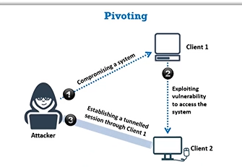

1. **Relaying**

Relaying involves capturing and forwarding authentication tokens or credentials from one machine to another to gain unauthorized access. This technique exploits trust between systems, allowing attackers to impersonate legitimate users and access resources without needing to crack passwords, thereby bypassing standard authentication mechanisms.

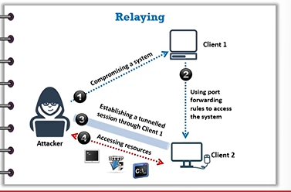

**Executing Applications:**

In cybersecurity and ethical hacking, executing applications refers to running software or scripts—often designed to test system security. This includes launching tools for vulnerability scanning, exploitation, or malware simulation to assess defenses, identify weaknesses, and improve overall security.

Tools for executing applications:

1. Dameware remote support
2. Ninja
3. Pupy
4. PDQ Deploy
5. ManageEngine Desktop Central
6. PsExec

**Keylogger:**

A keylogger is a malicious program or hardware tool that records keystrokes on a target device, capturing sensitive data like passwords or messages. Cybercriminals use it for unauthorized access, while ethical hackers test systems with it to identify security vulnerabilities and prevent attacks.

We can use Metasploit to do so, hardware keylogger etc.

**Spyware:**

Spyware is malicious software that covertly monitors user activities, collecting sensitive information like passwords, browsing habits, or financial data. It can spread via phishing, malicious downloads, or software vulnerabilities.

Spyware tools are: Spytech SpyAgent and Power Spy

**Rootkits:**

A rootkit is malicious software that grants attackers unauthorized, stealthy access to a system by hiding processes, files, or activities. It often operates at the kernel level, making it hard to detect and remove.

How root kit works?

A rootkit works by infiltrating a system and embedding itself deep within the operating system, often at the kernel or firmware level. It modifies system processes, files, or drivers to hide its presence and grant attackers continuous, privileged access. Rootkits intercept system calls, allowing attackers to execute commands or steal data without detection, while disabling security tools like antivirus programs. They are typically installed through phishing, malicious downloads, or exploiting vulnerabilities.

**NTFS data streams:**

NTFS data streams are alternate data storage methods in NTFS file systems, allowing multiple data streams within a single file. Attackers can use them to hide malicious code or data without changing file size, making detection challenging. Security tools are essential for identification.

**Steganography:**

Steganography is the practice of concealing data within ordinary files, such as images, audio, or videos, to avoid detection. Unlike encryption, the hidden information remains invisible. Attackers use it to covertly transmit data, while cybersecurity experts analyze files to uncover such hidden content.

Some tools are:

1. Whitespace Steganography -> cmd
2. Image Steganography -> OpenStego
3. Document Steganography -> StegoStick

Steganography detection tools:

1. Zsteg
2. StegoVeritas
3. Stagextract
4. StegoHaunt MP
5. Steganography studio
6. VSL

**Golden Ticket attack:**

A Golden Ticket attack is a Kerberos exploitation technique where attackers forge valid authentication tickets using stolen domain admin credentials and the KRBTGT hash. This grants unrestricted access to any system within the domain, bypassing authentication. It is difficult to detect and enables long-term persistence in compromised networks.

**Silver Ticket attack:**

A Silver Ticket attack is a Kerberos exploitation technique that allows attackers to forge service tickets (TGS) to gain unauthorized access to specific services within a network. Unlike Golden Tickets, which provide domain-wide access, Silver Tickets are limited to a single service. Attackers obtain the necessary service account credentials and use them to create forged tickets, enabling access to sensitive resources without alerting administrators. This attack can remain undetected if proper monitoring is not in place, making it a significant threat to network security.

**Using InvisibleSecrets4:**

Steganography is a technique by which we can hide sensitive information to the receiver using the normal image file.

How does steganography work? The secret is converted to binary form and embedded in the picture from the start of the pixel, and so on.

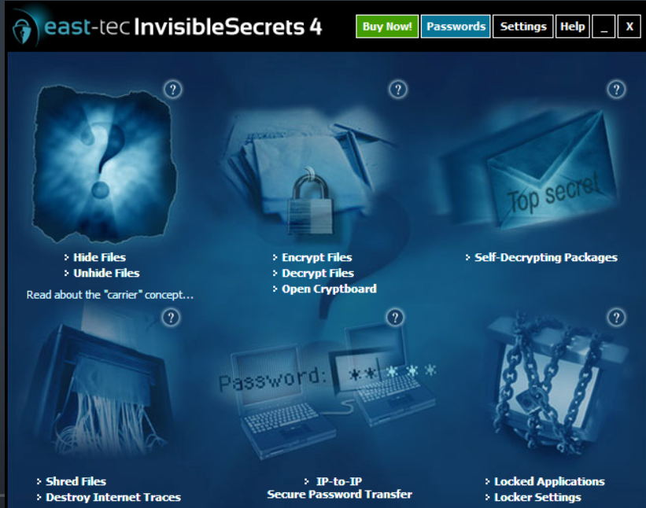

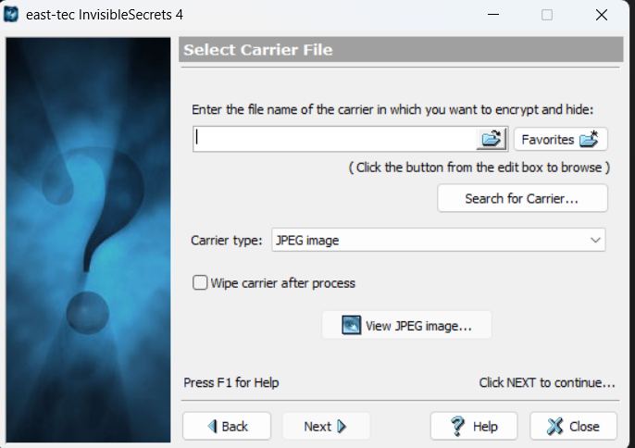

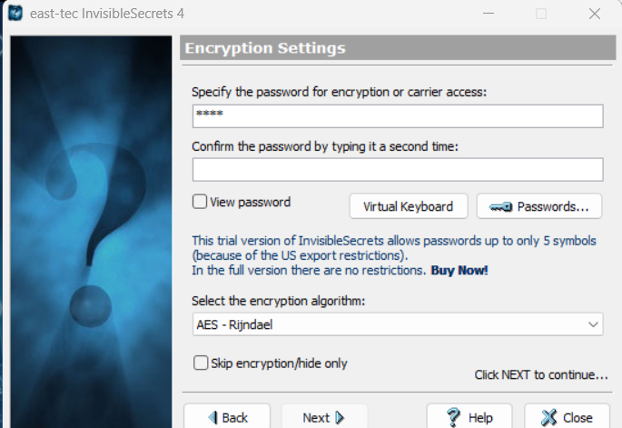

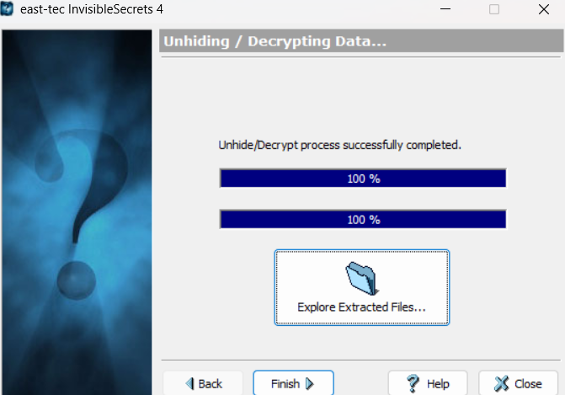

**Using Stegosuite:**

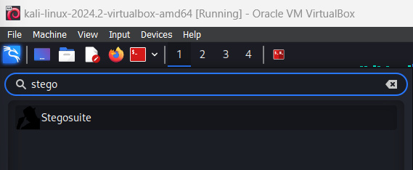

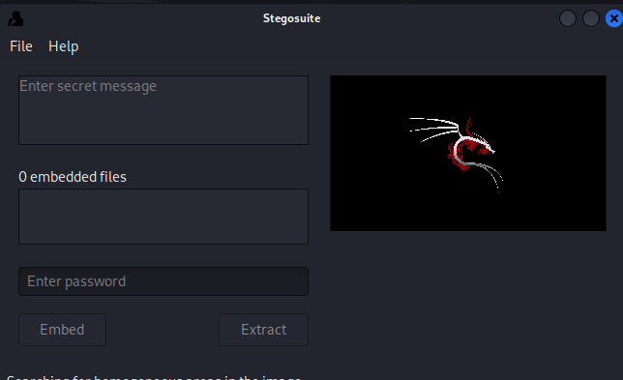

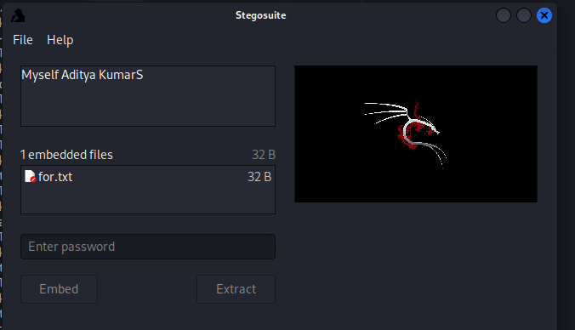

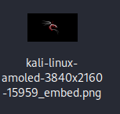

**Using John-the-ripper:**

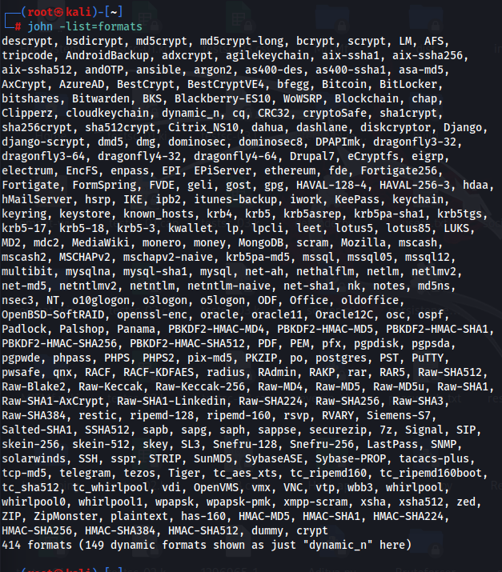

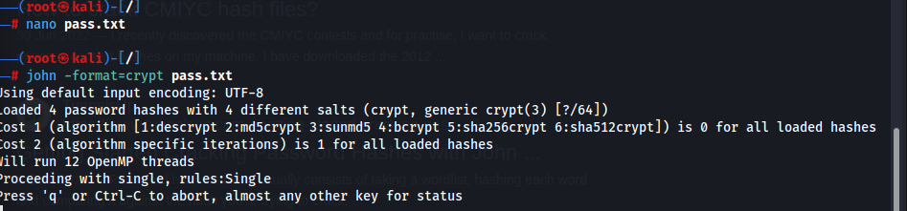

**Audit system passwords using L0phtCrack:**

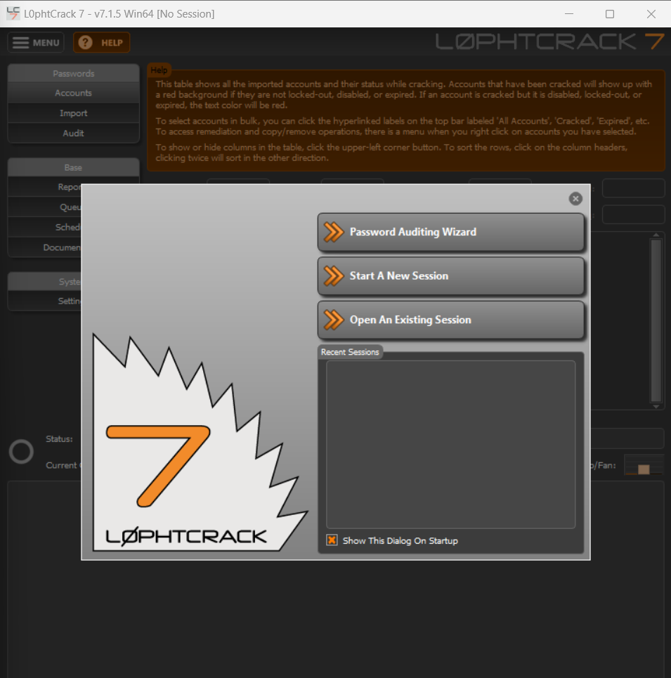

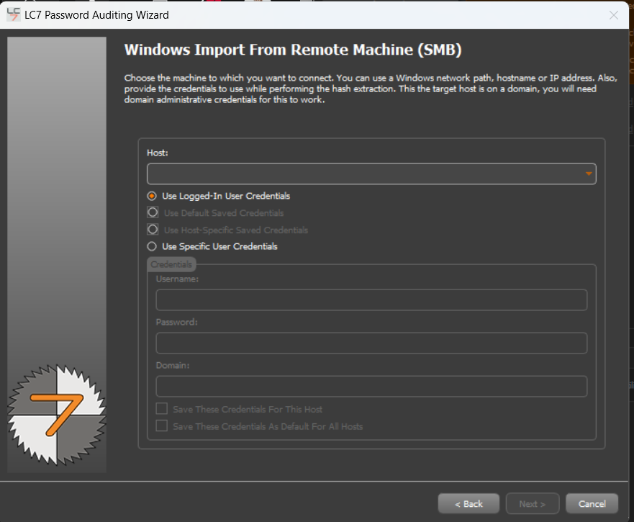

**Find Vulnerabilities on Exploit Sites:**

<https://www.exploit-db.com/>

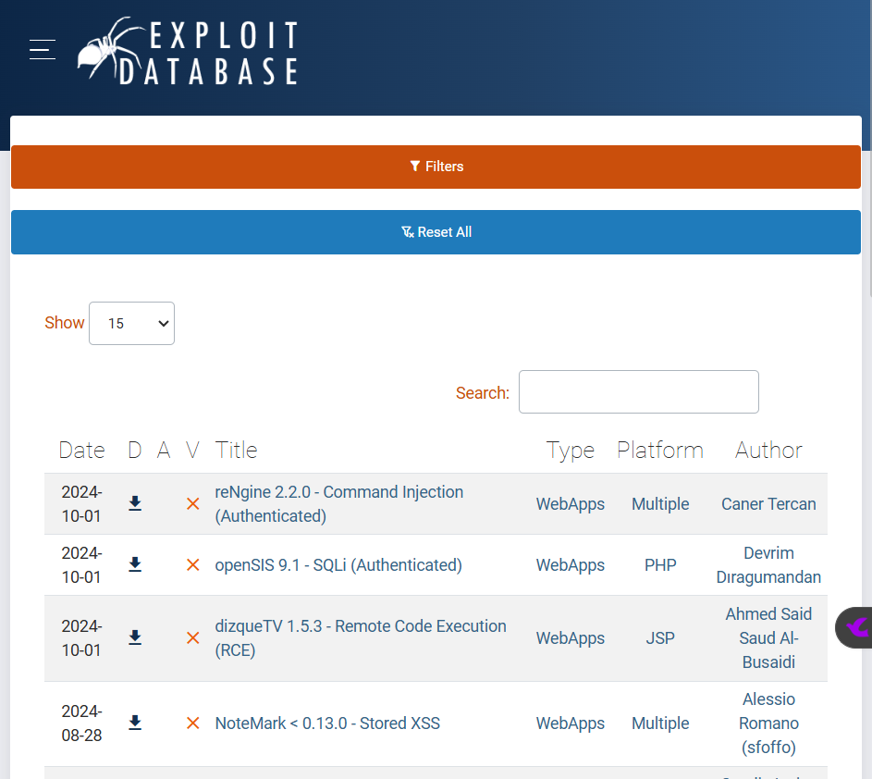

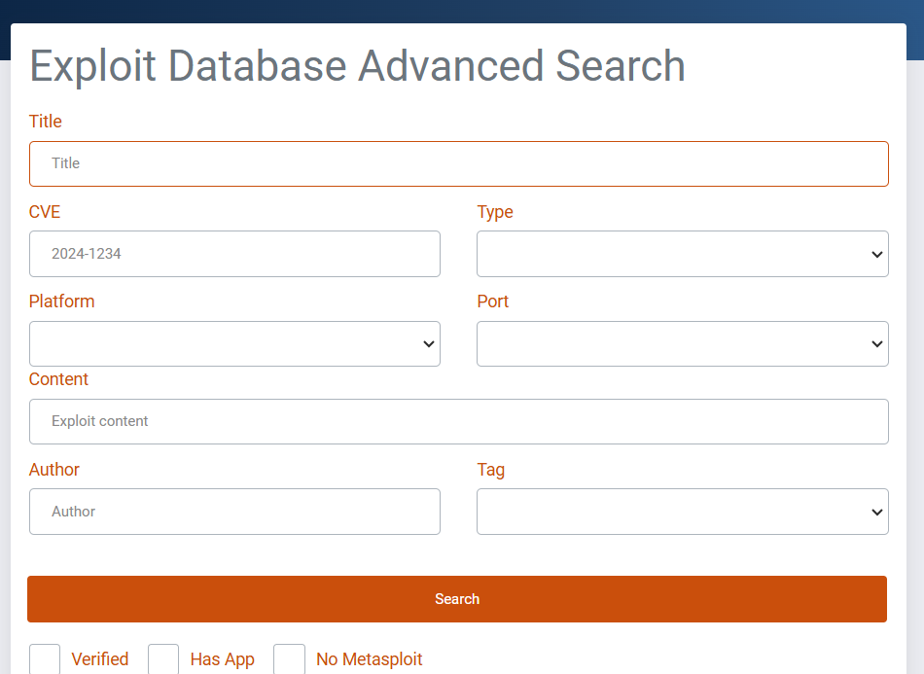

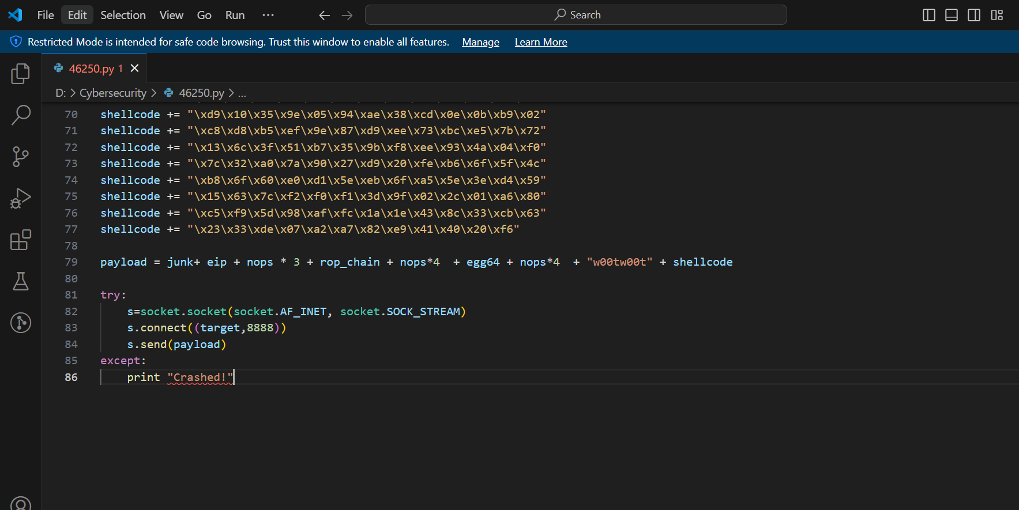

**Exploit Client-Side Vulnerabilities and Establish a VNC Session:**

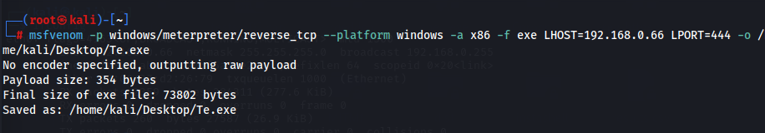

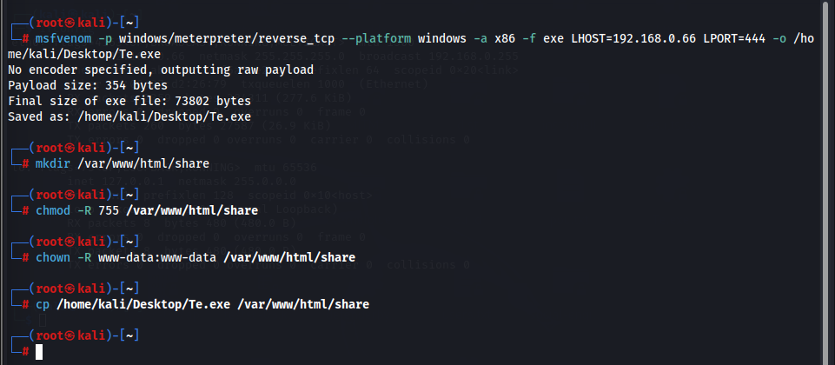

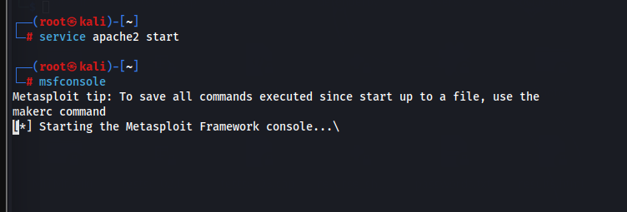

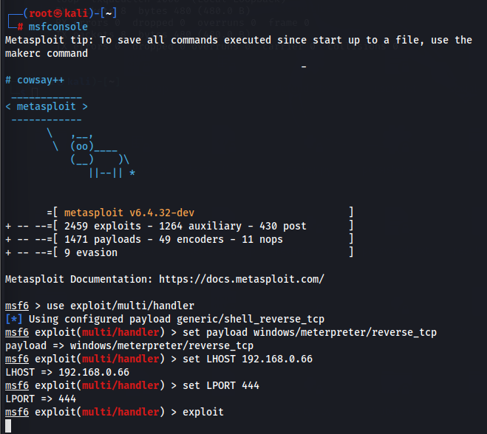

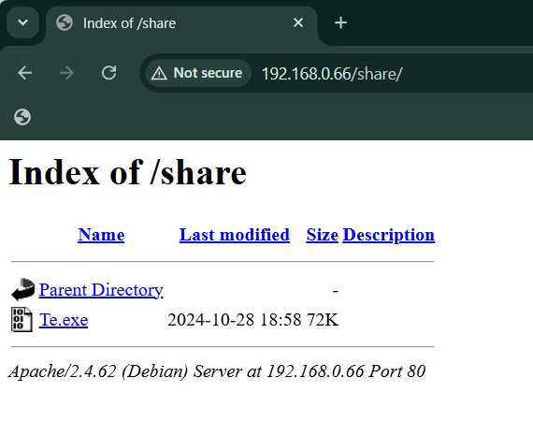

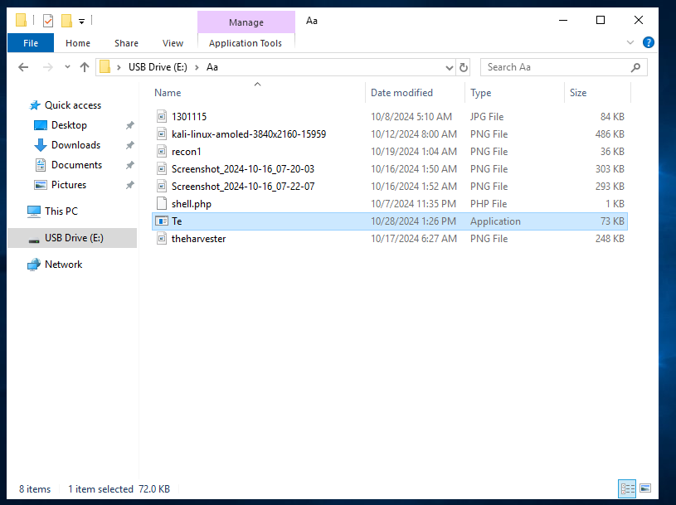

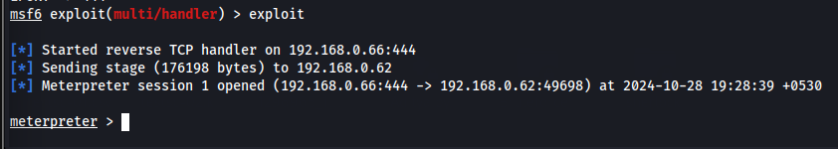

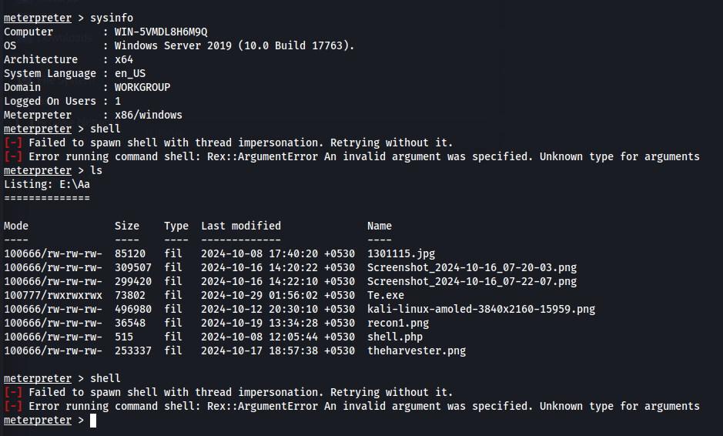

**Gain Access to a Remote System using Ninja Jonin:**

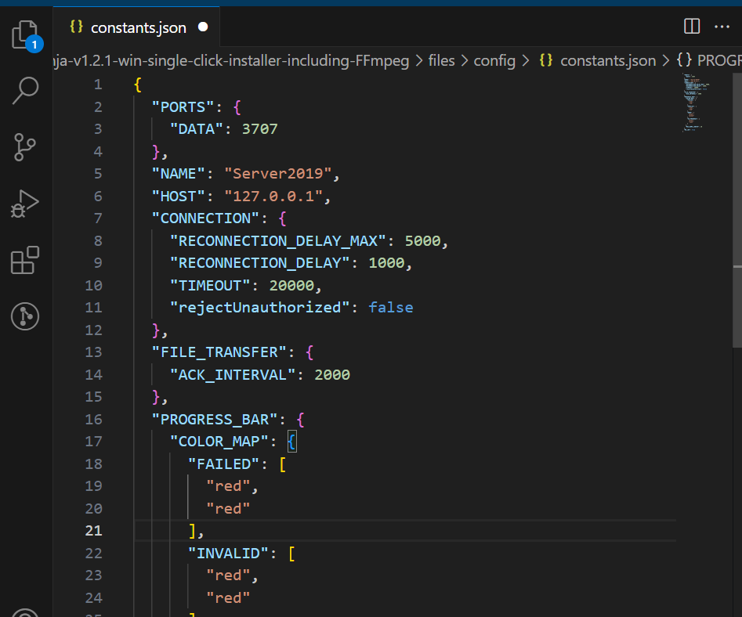

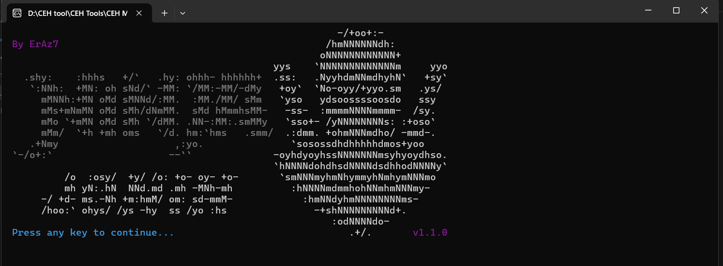

**Perform Buffer Overflow Attack to Gain Access to a Remote System:**

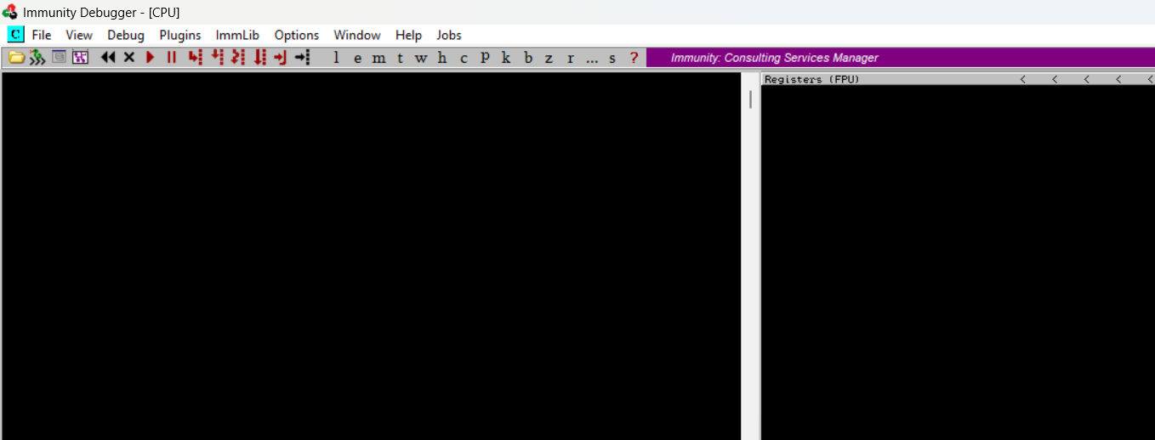



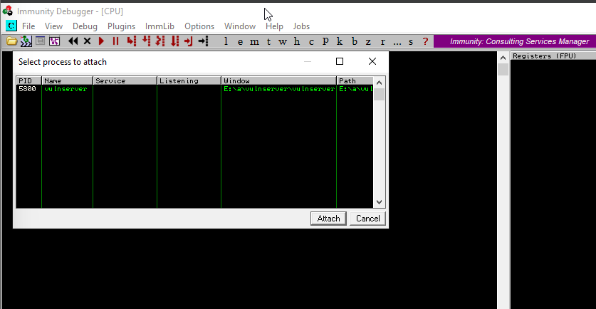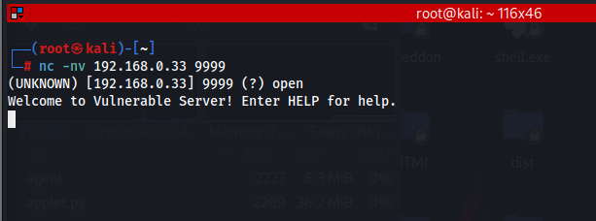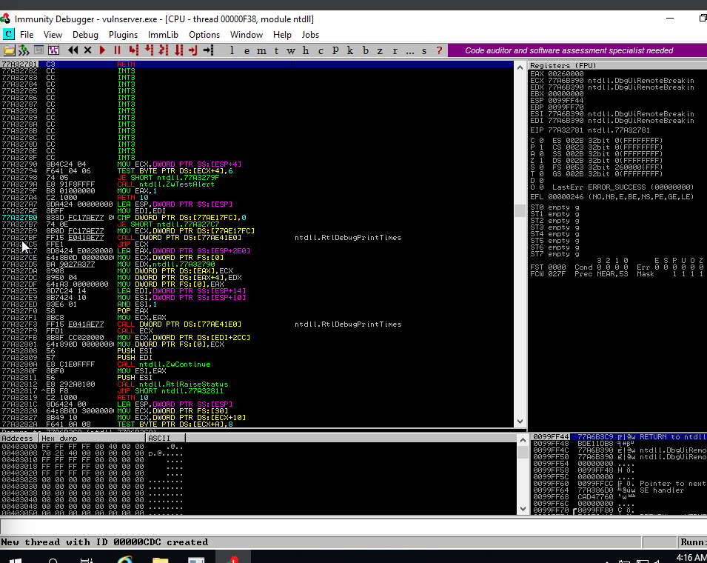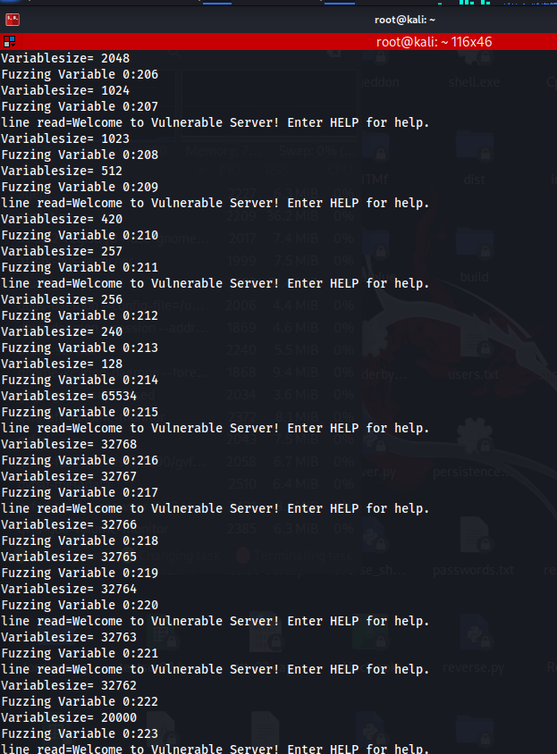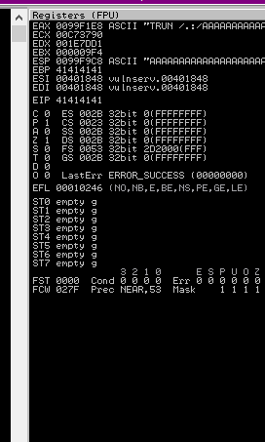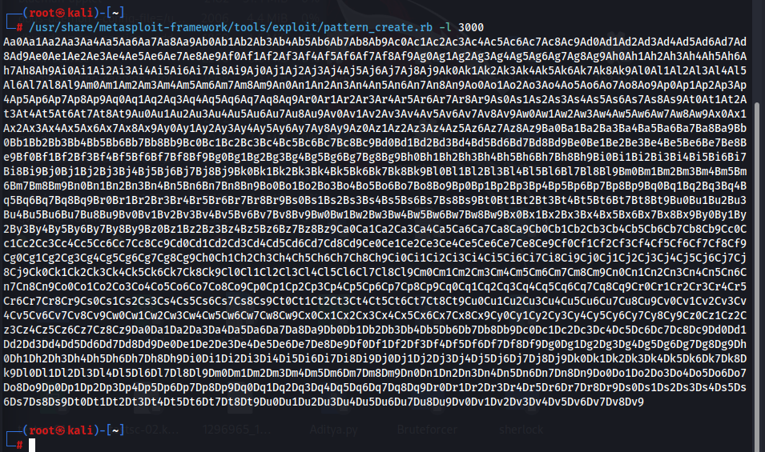

**Privilege Escalation Tools and Exploit Client-Side Vulnerabilities:**

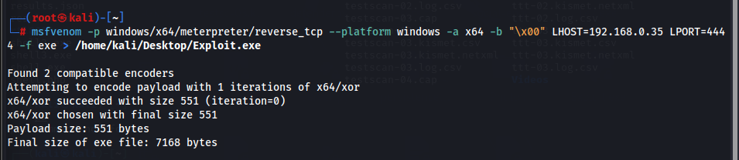

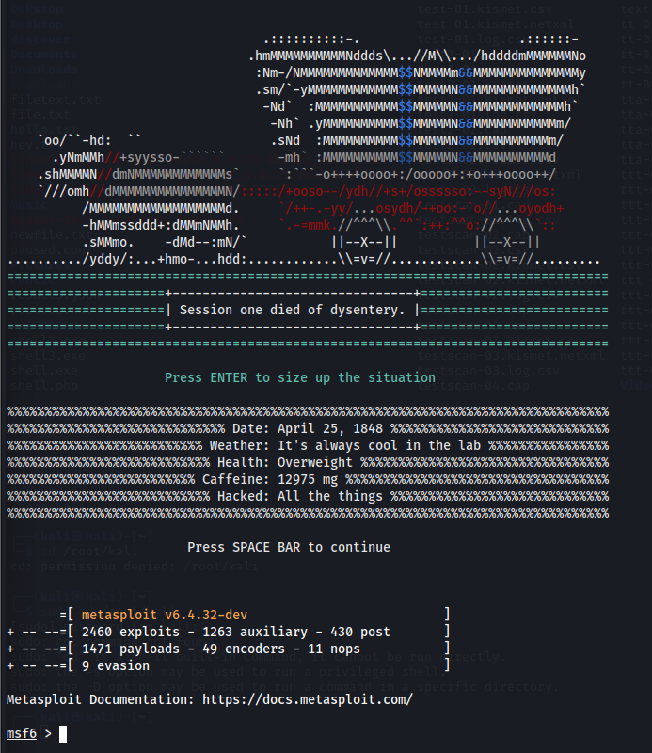

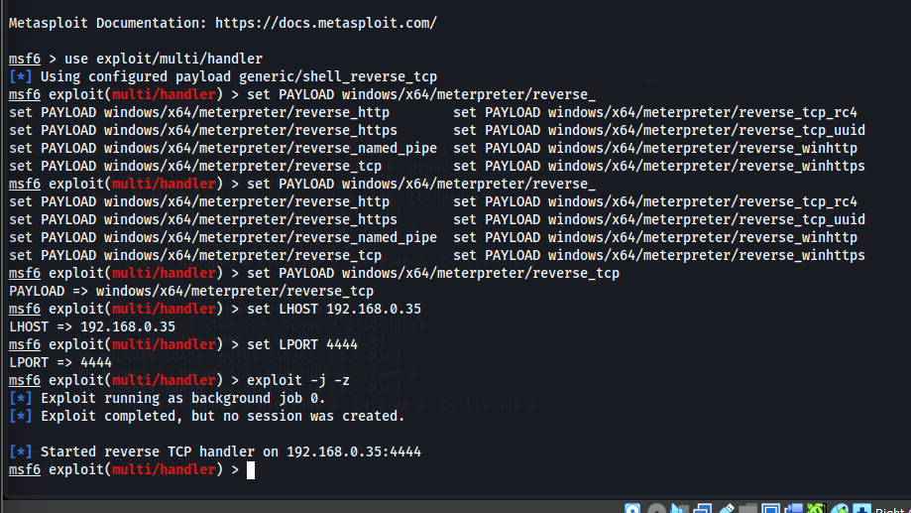

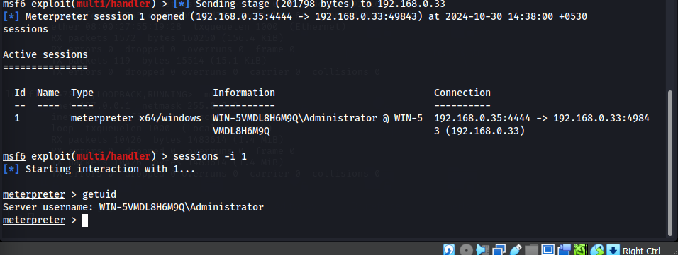

**Hack Win w/Metasploit & Perform Post-Exploitation w/ Meterpreter:**

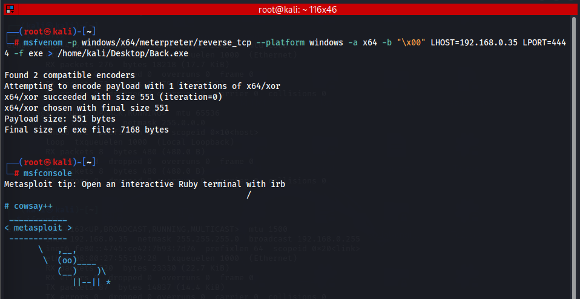

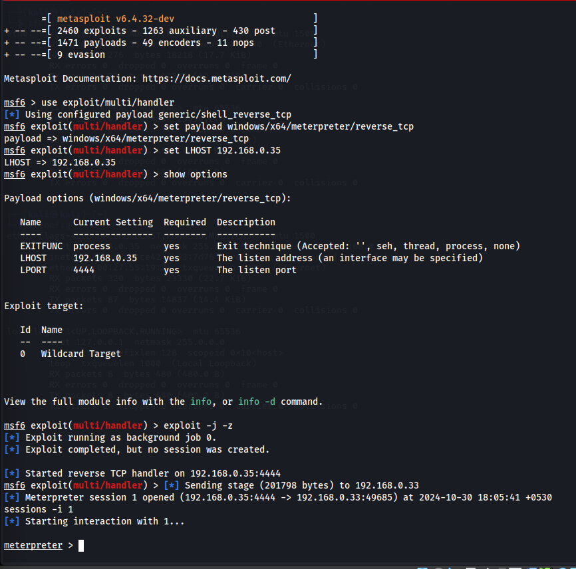

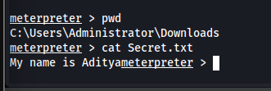

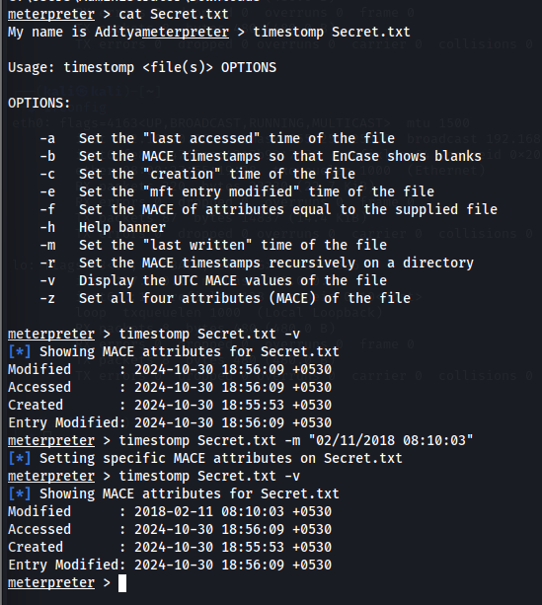

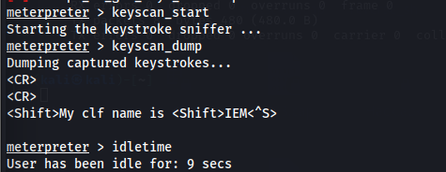

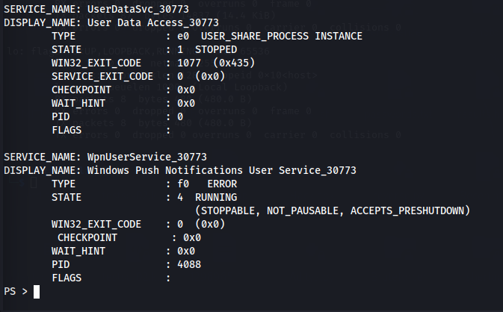

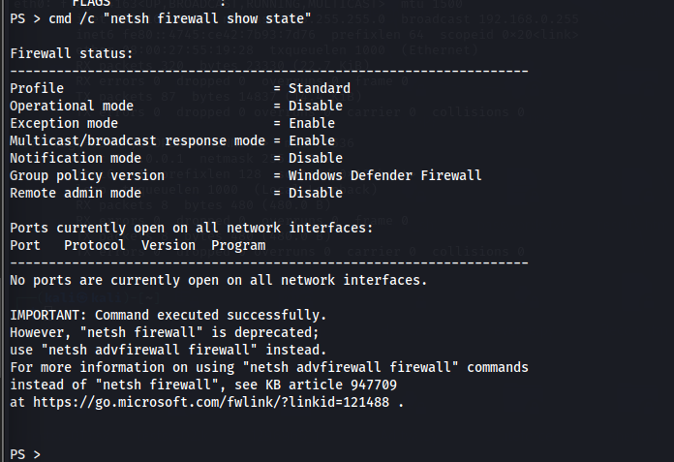

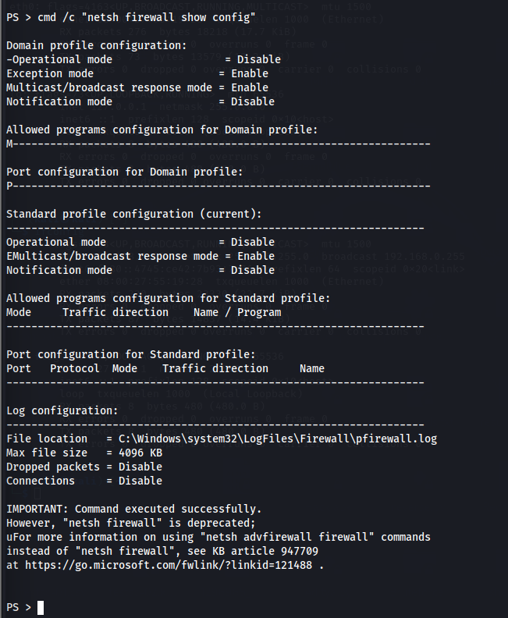

**Escalate Privileges by Exploiting Vulnerability in pkexec:**

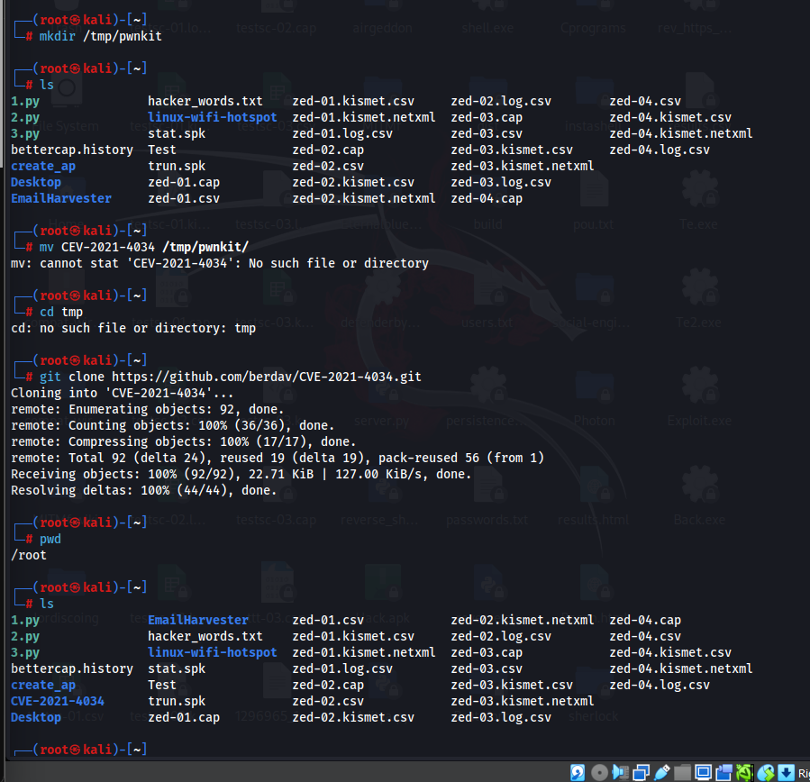

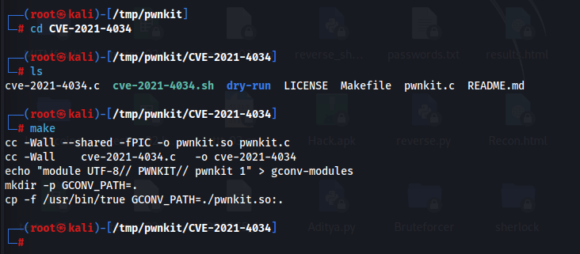

**Escalate Privileges in Linux by Exploiting Misconfigured NFS:**

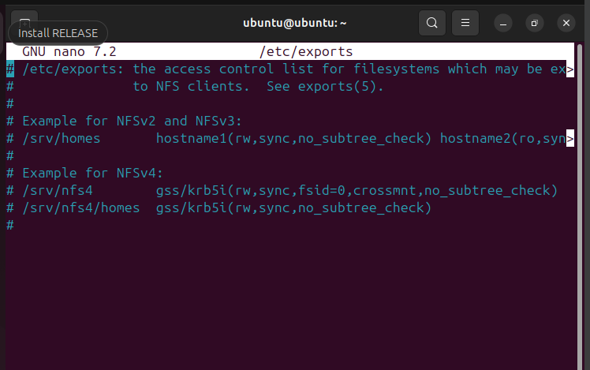

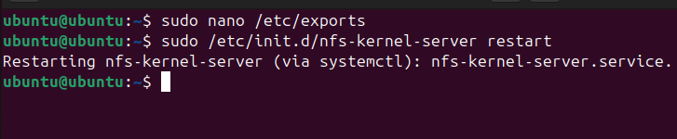

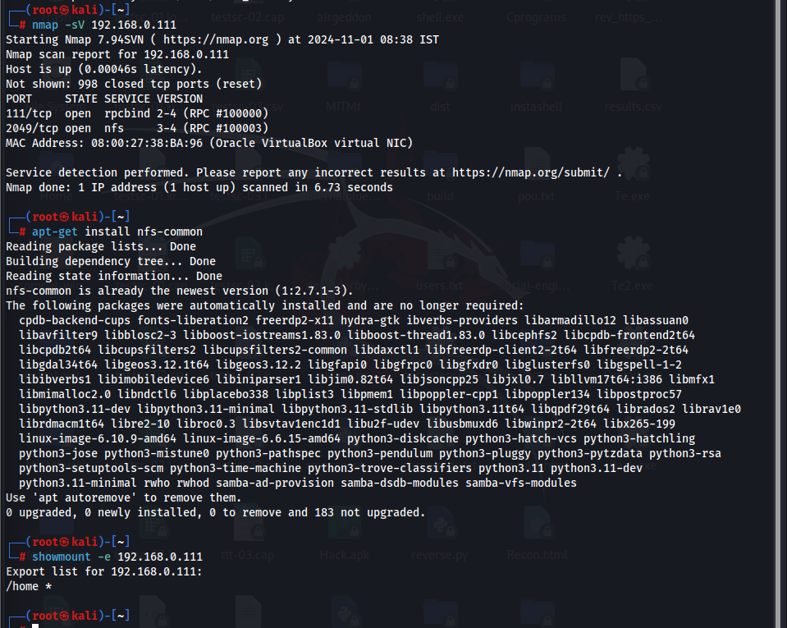

**Escalate Privileges by Bypassing UAC and Exploiting Sticky Keys:**

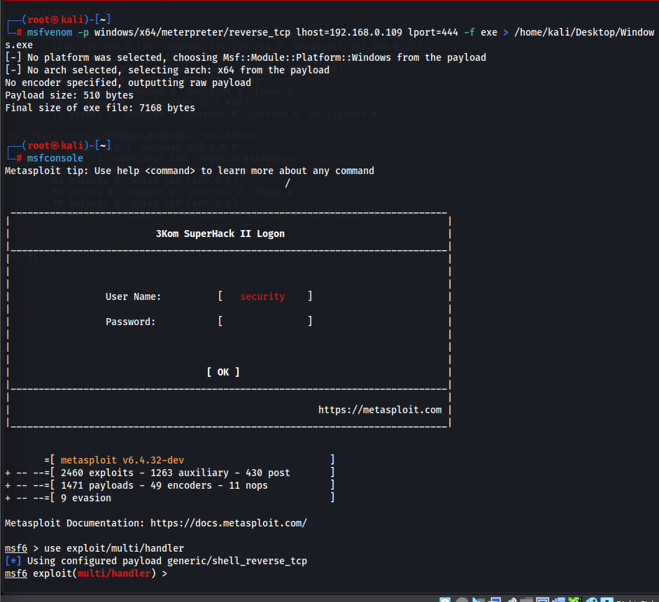

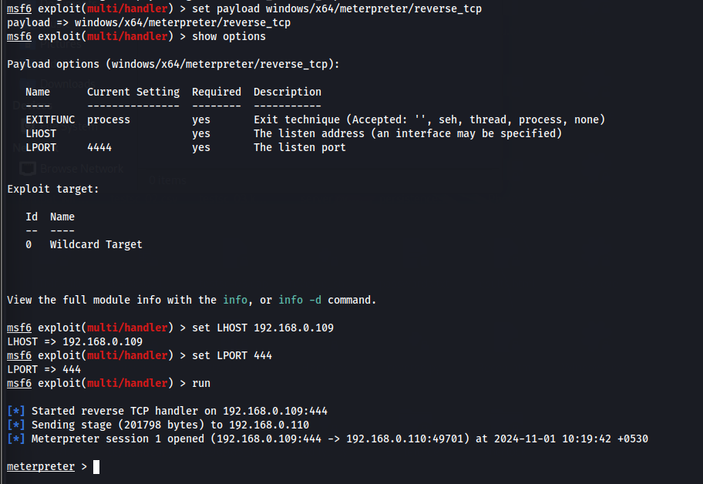

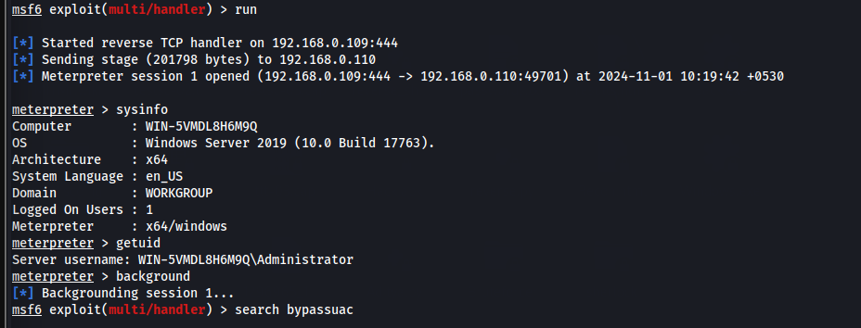

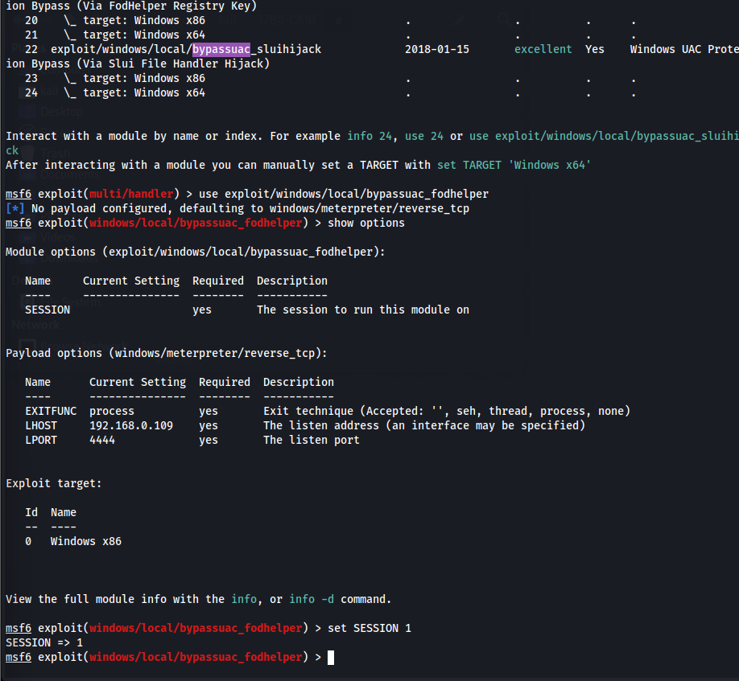

**Escalate Privileges to Gather Hashdump using Mimikatz:**

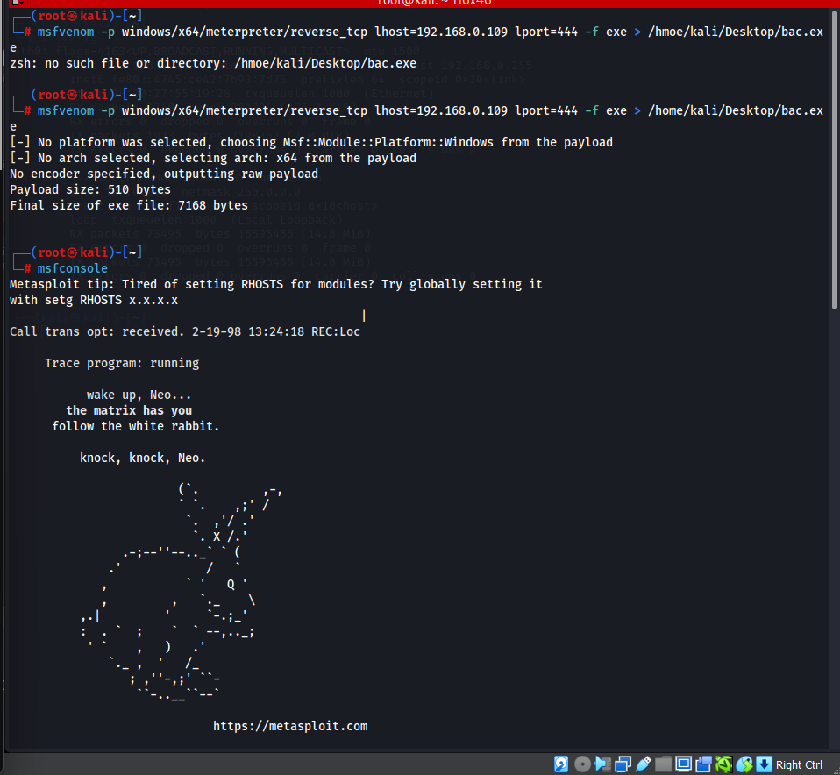

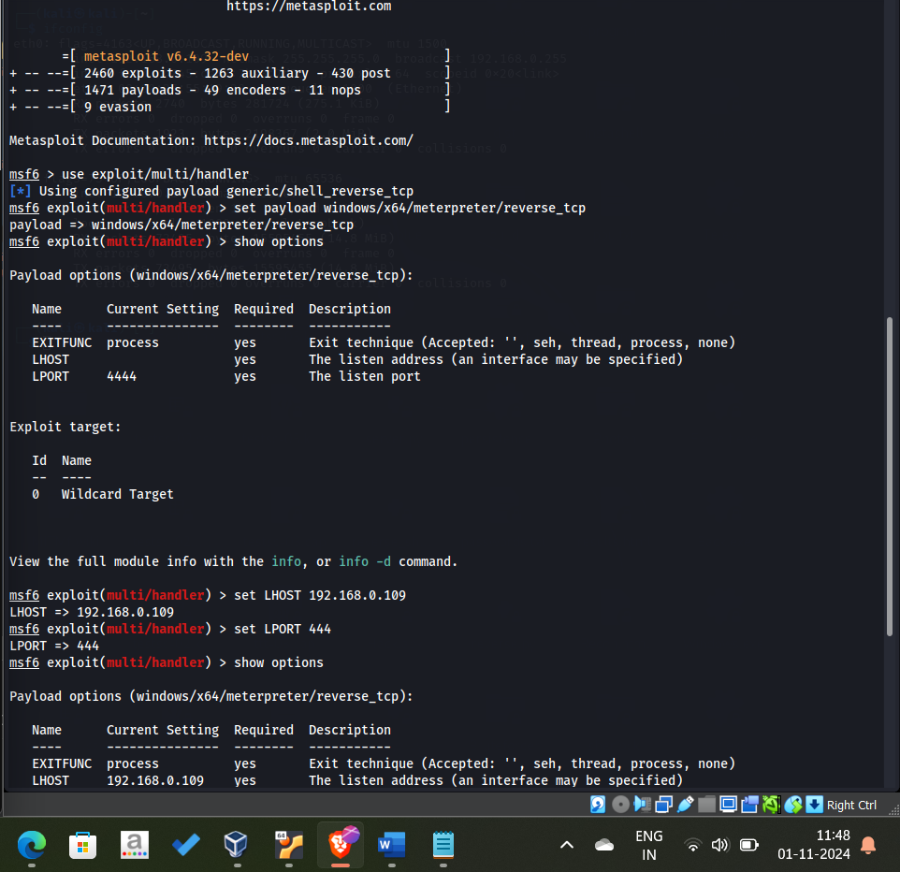

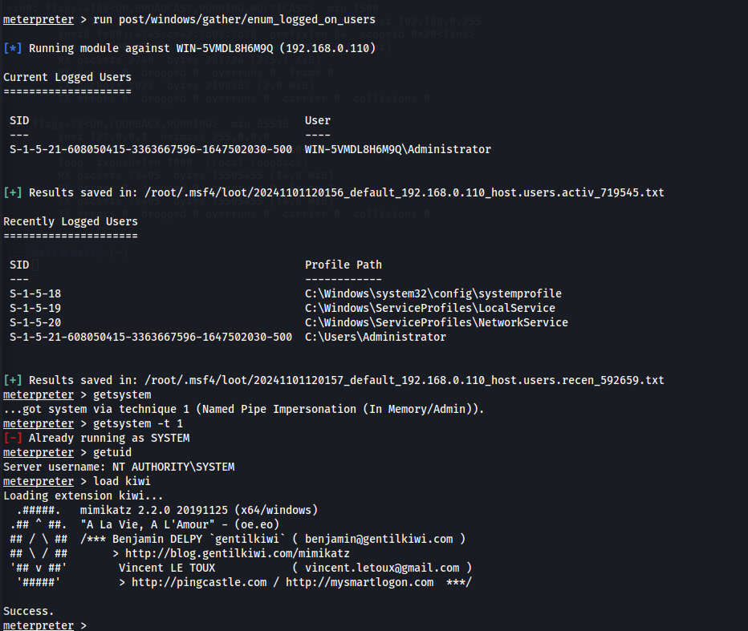

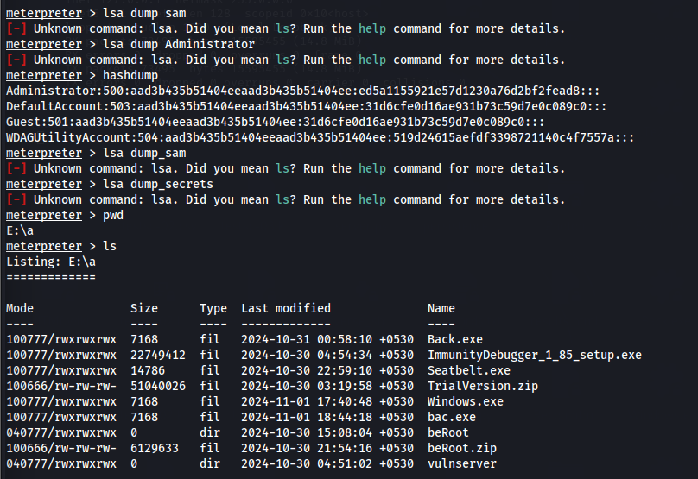

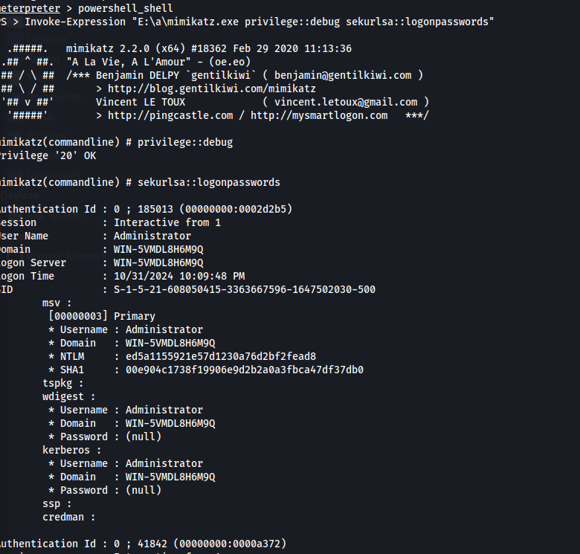

**User System Monitoring and Surveillance using Power Spy:**

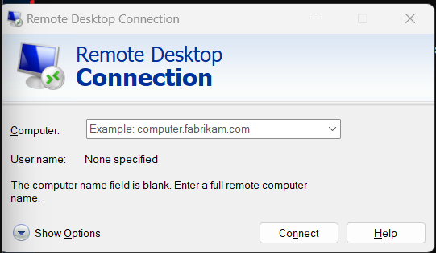

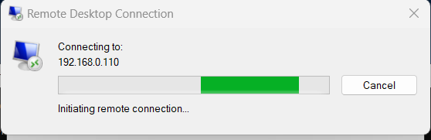

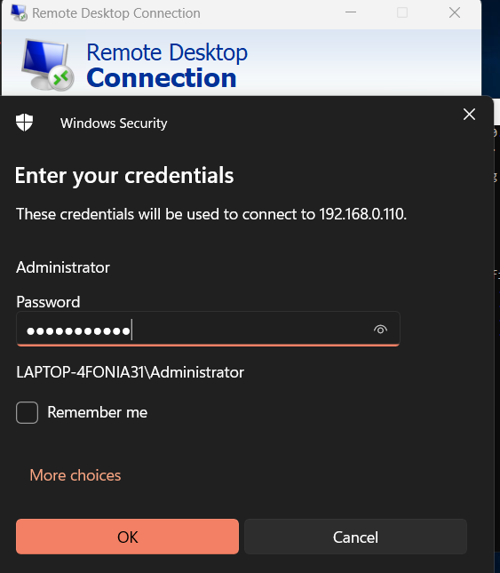

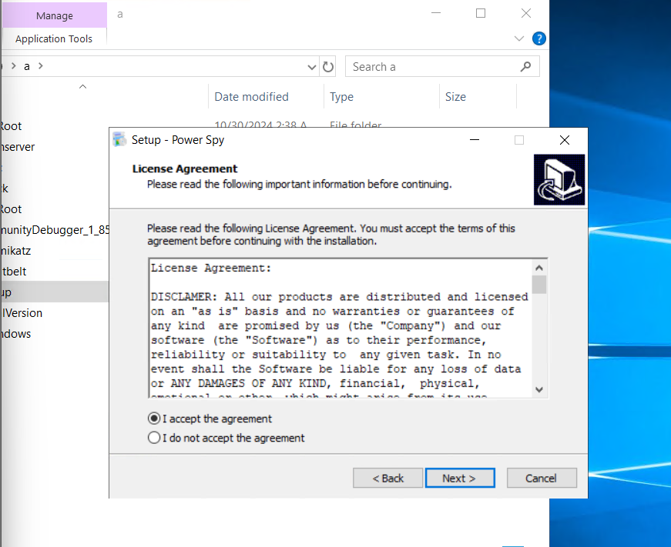

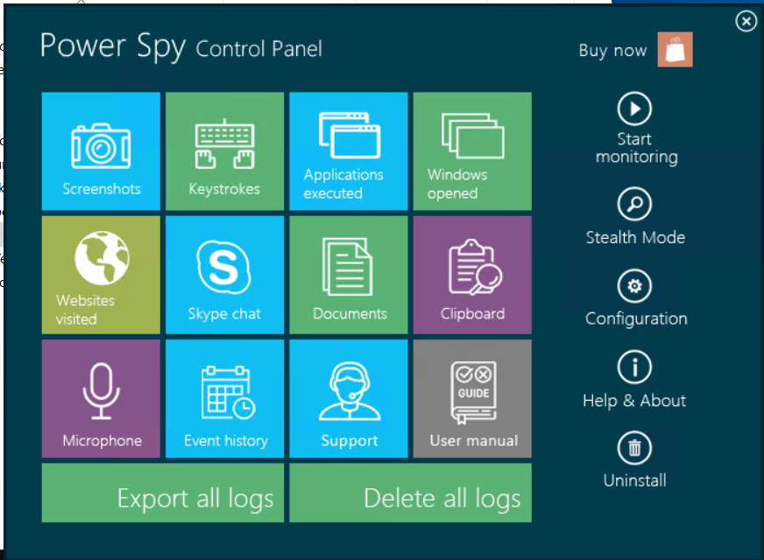

**User System Monitoring and Surveillance using Spytech SpyAgent:**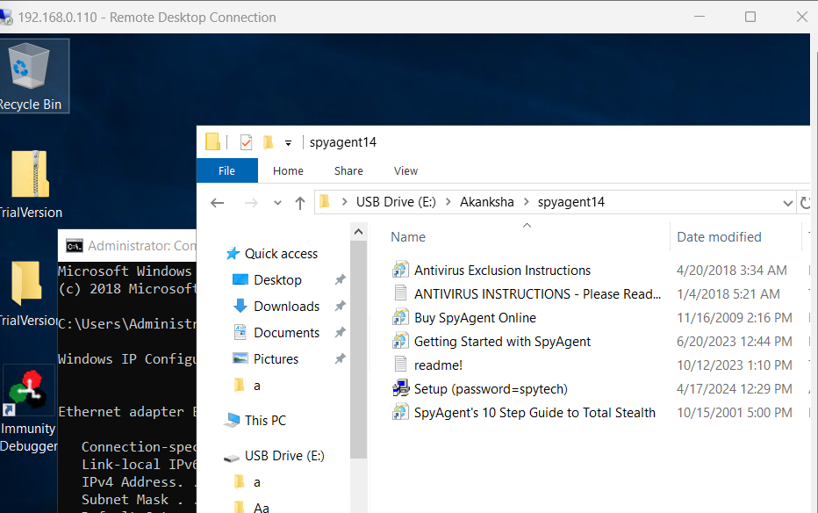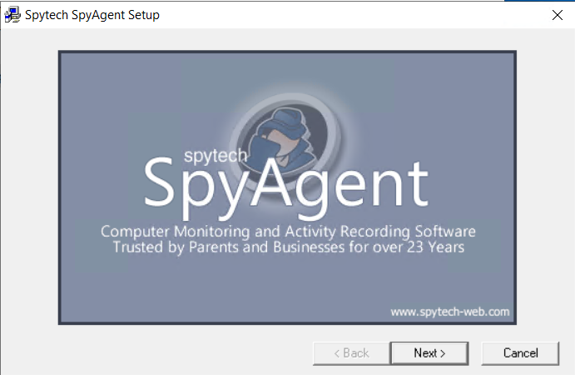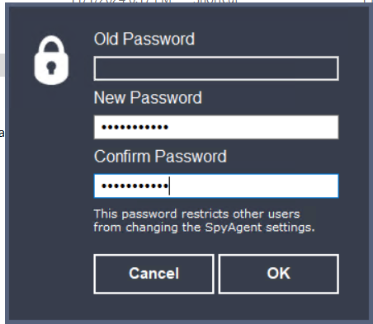

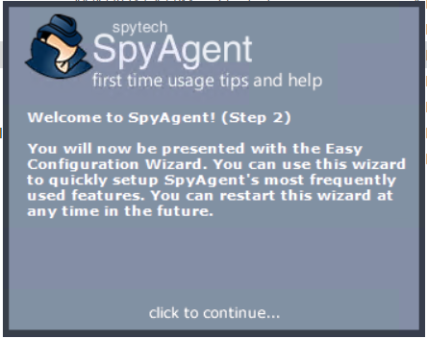

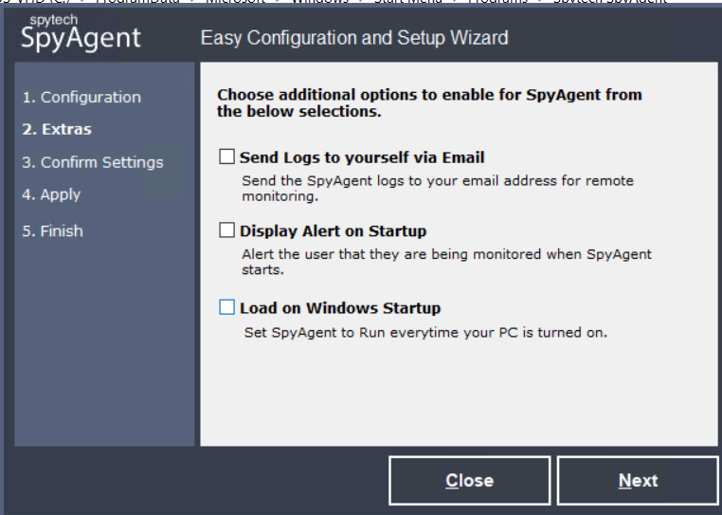

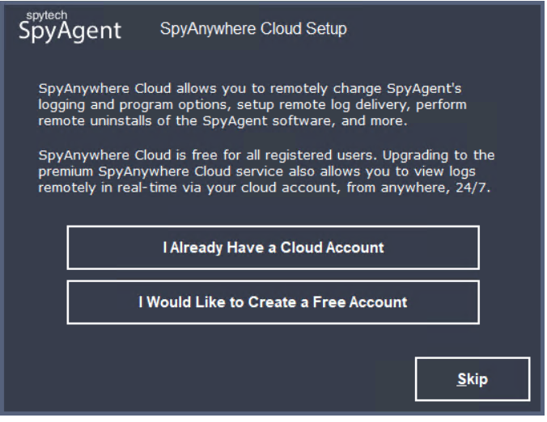

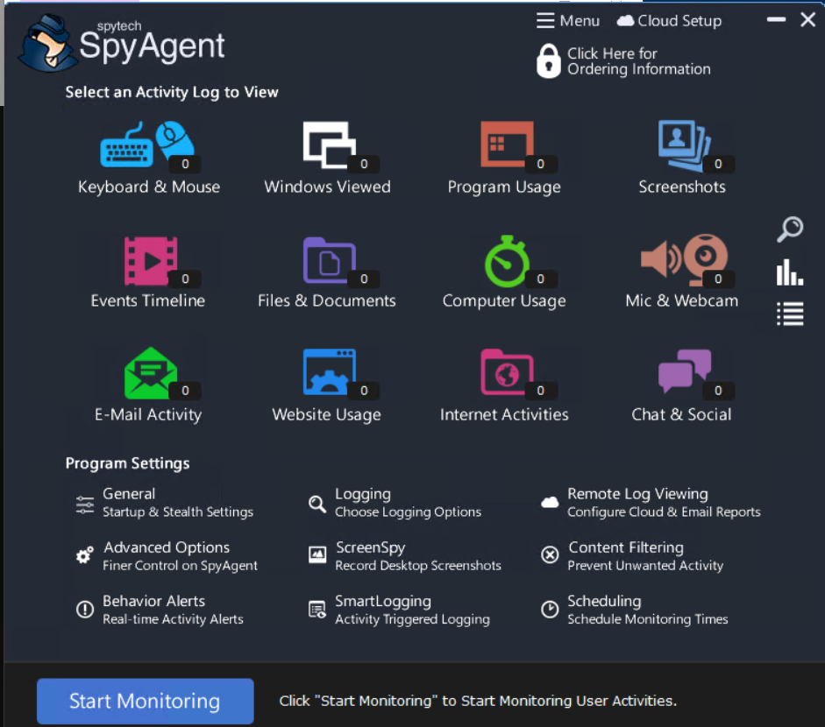

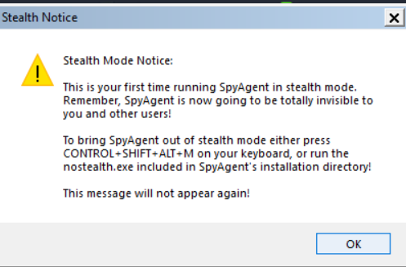

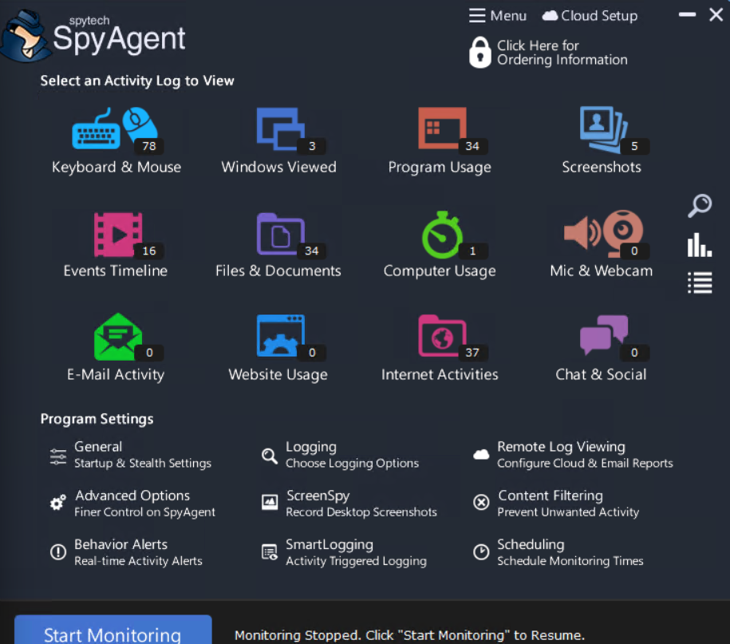

**Hide Files using NTFS Streams:**

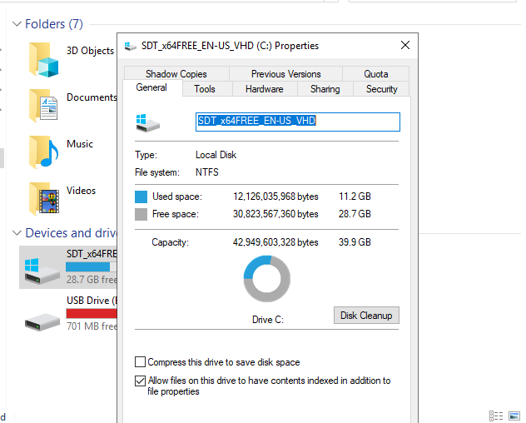

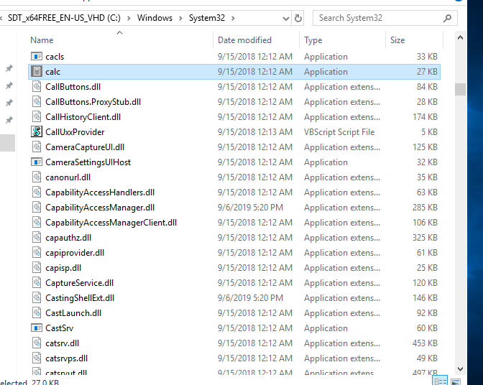

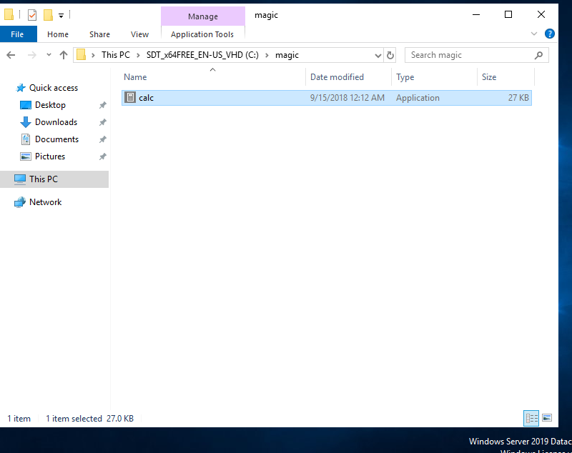

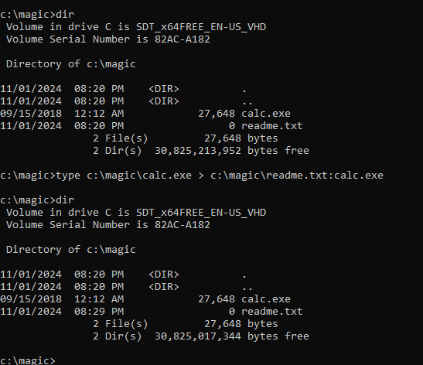

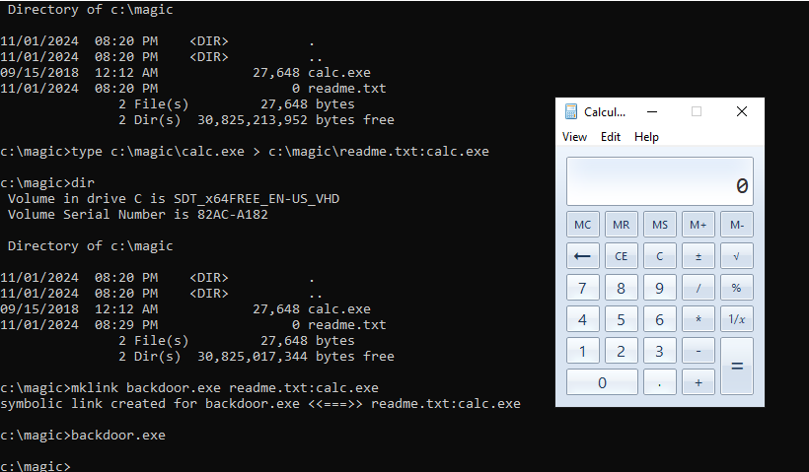

**Hide Data using White Space Steganography:**

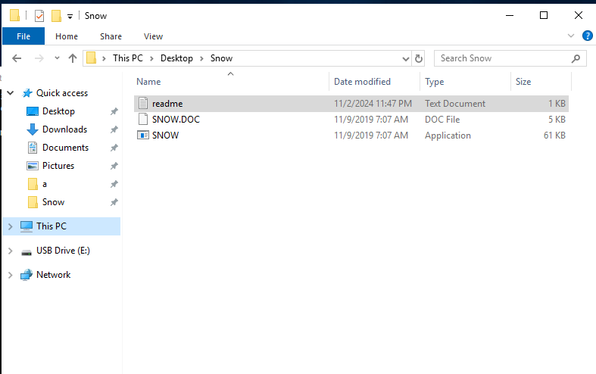

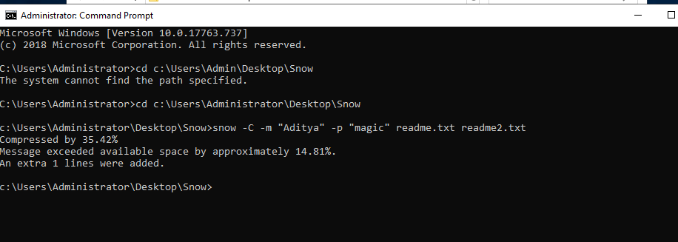

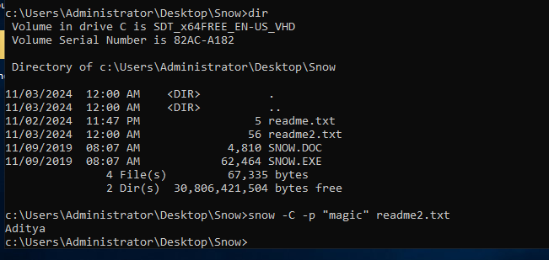

**Image Steganography using OpenStego and StegOnline:**

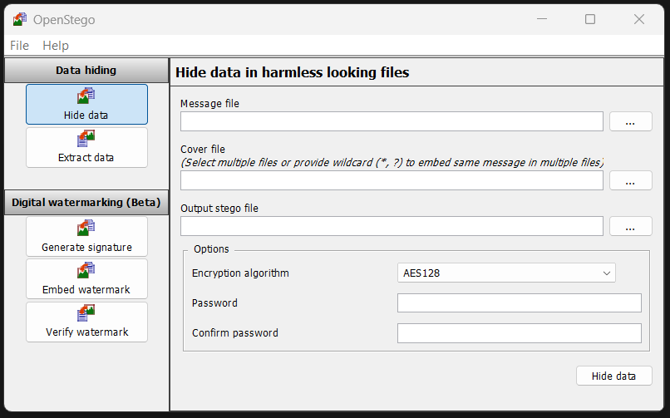

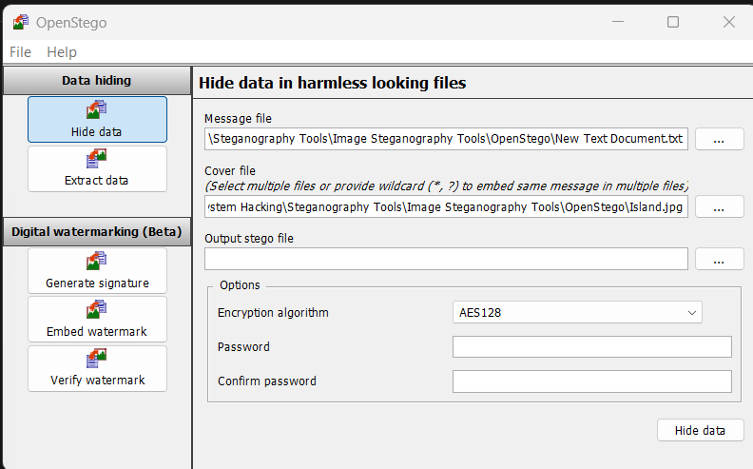

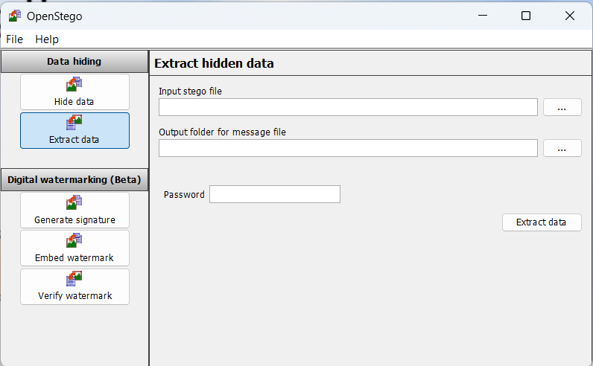

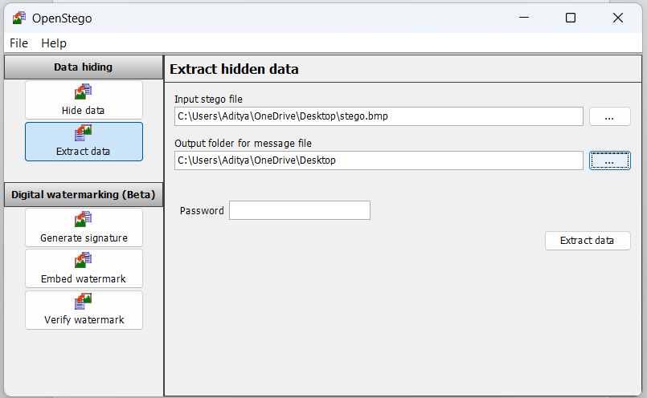

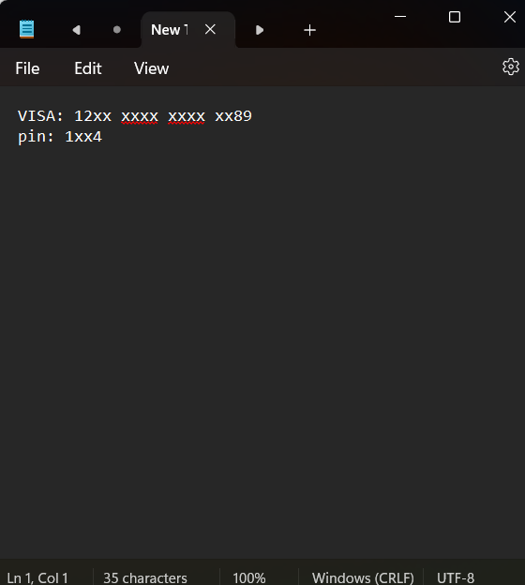

**Now, using Stegonline:**

<https://georgeom.net/StegOnline/upload>

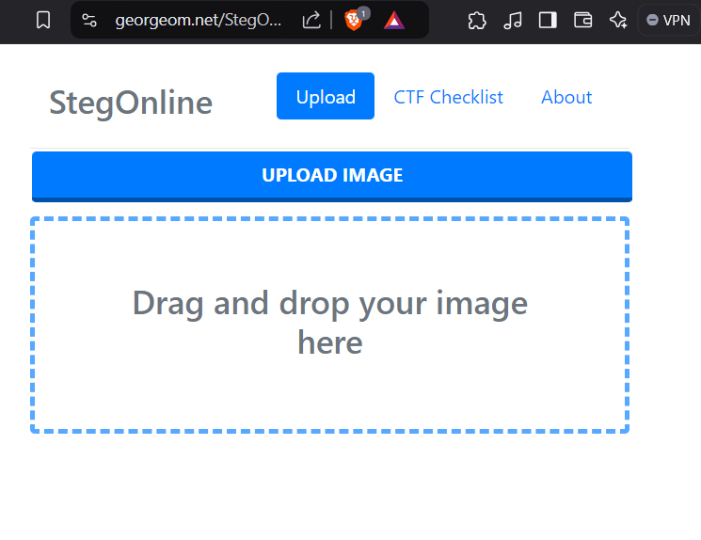

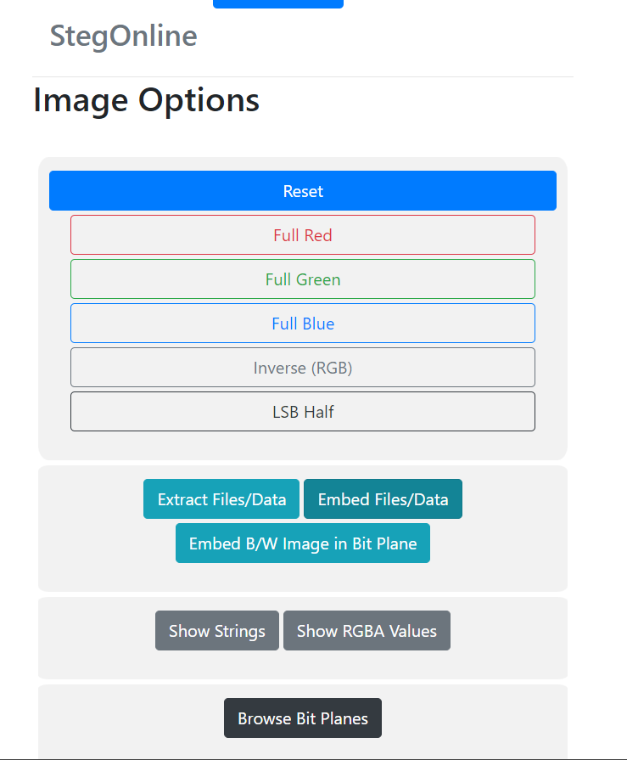

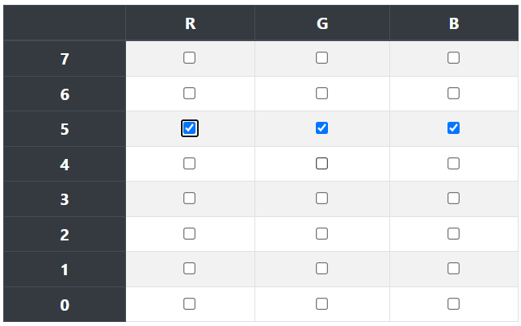

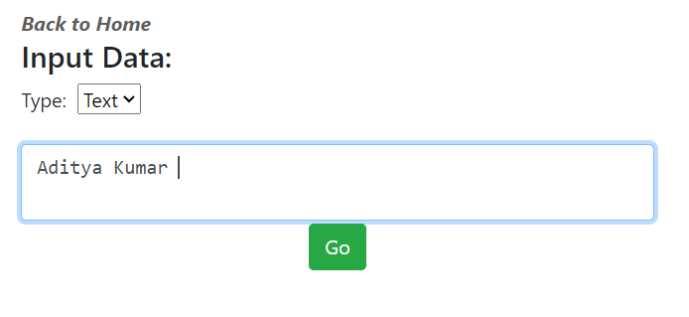

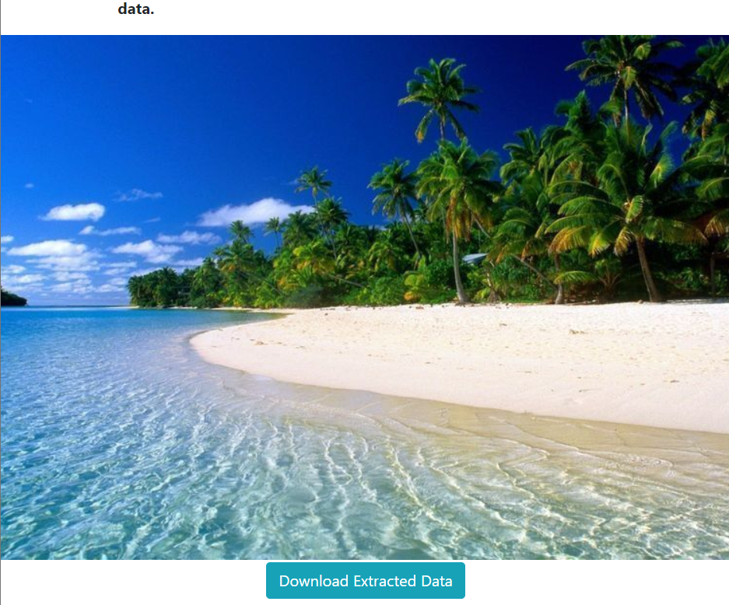

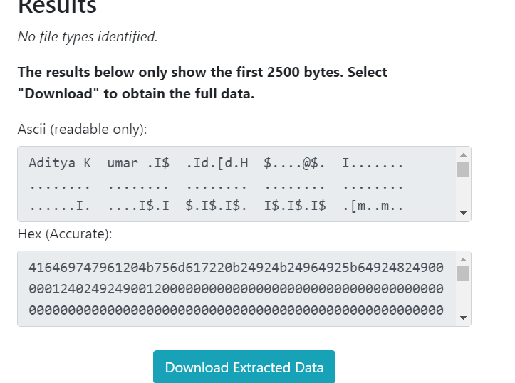

**Maintain Persistence by Abusing Boot or Logon Autostart Execution:**

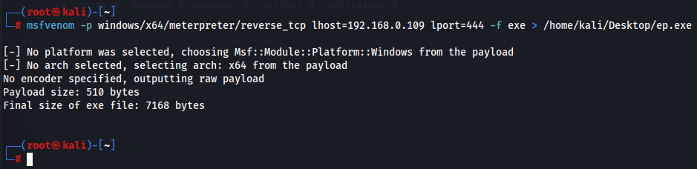

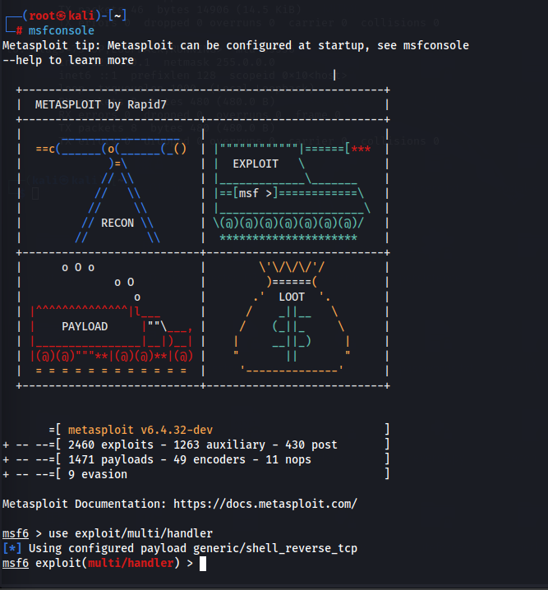

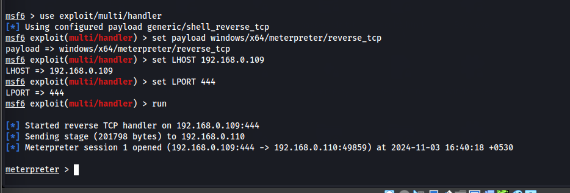

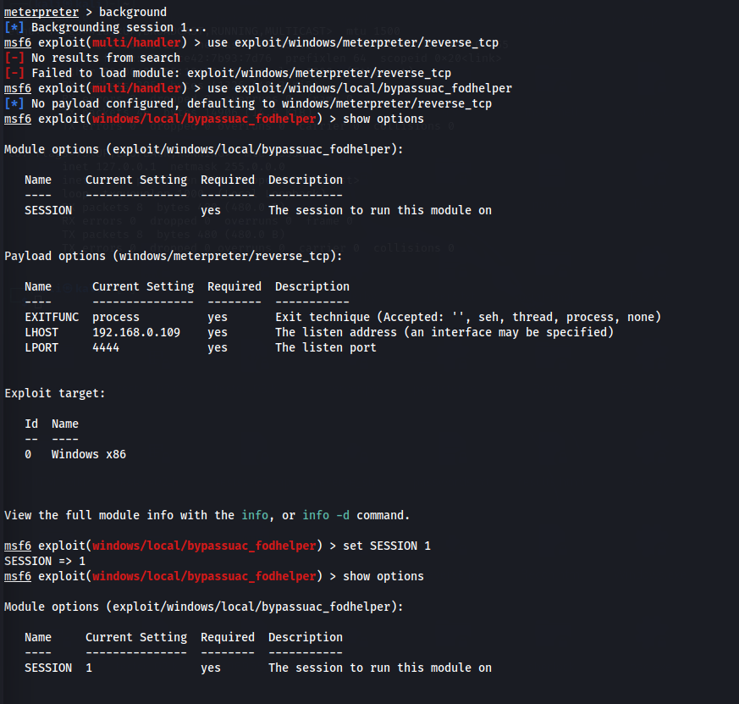

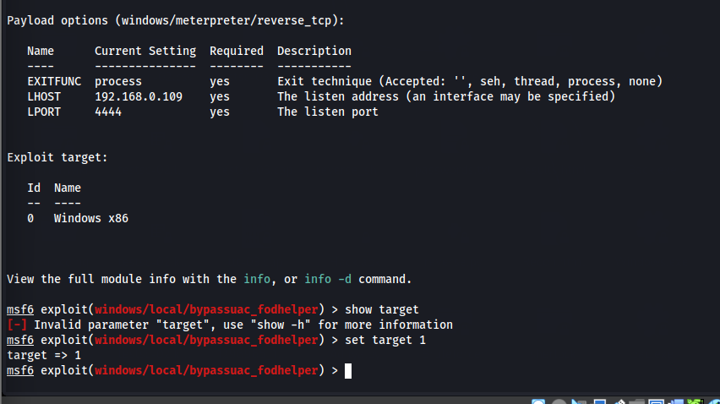

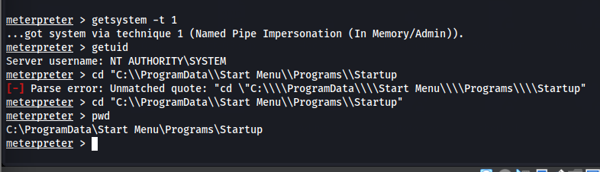

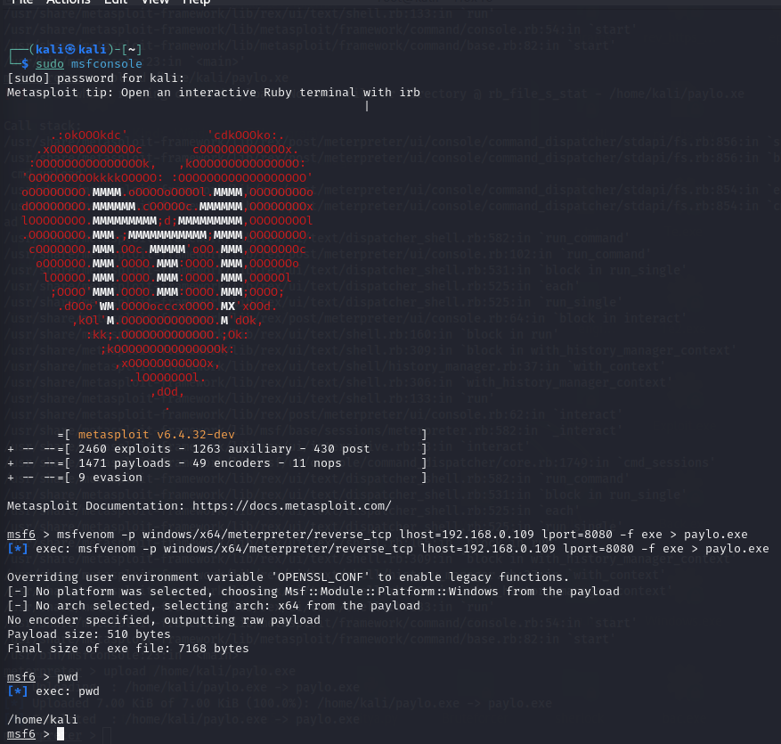

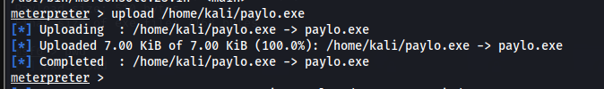

**Maintain Domain Persistence by Exploiting Active Directory Objects:**

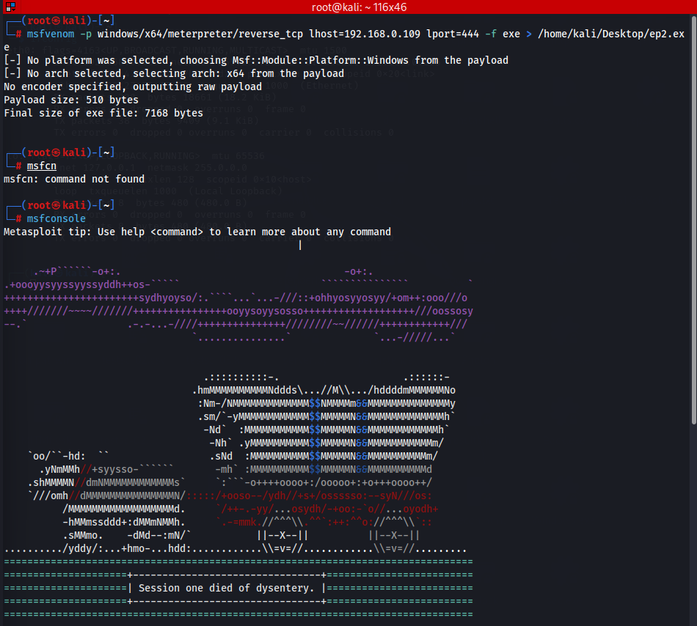

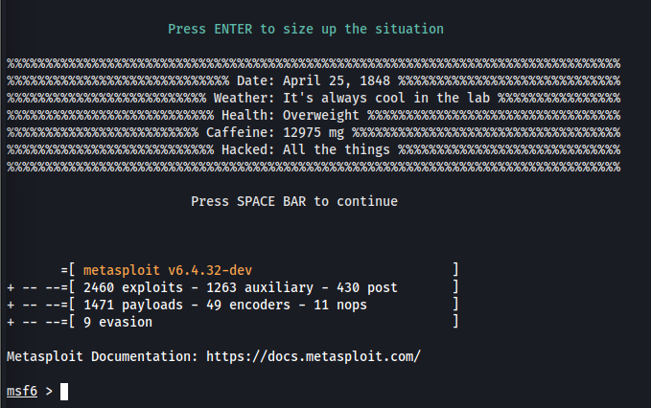

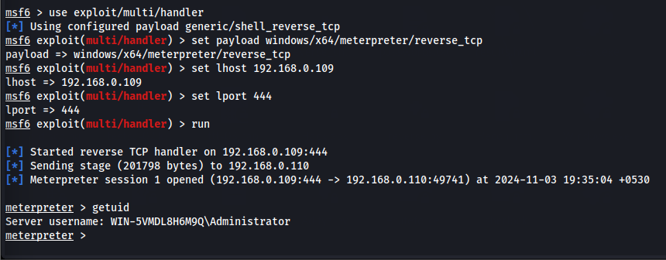

**Privilege Escalation and Maintain Persistence using WMI:**

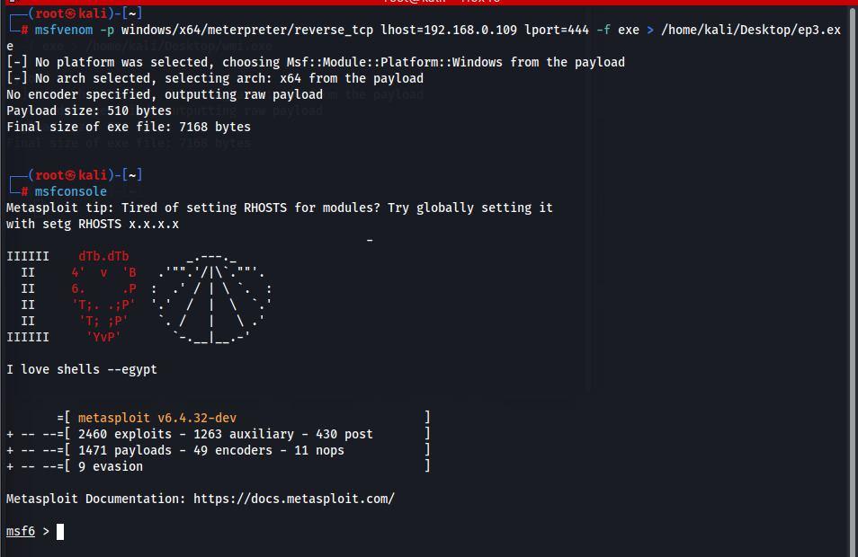

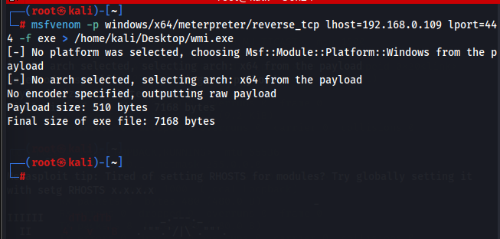

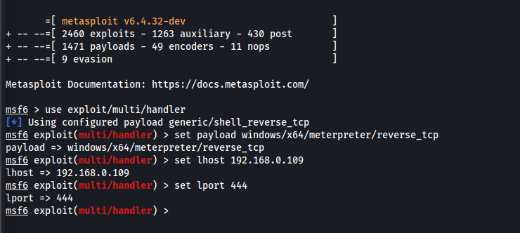

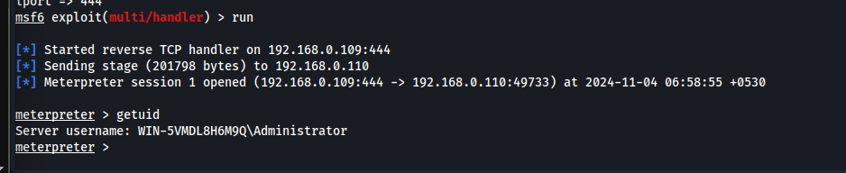

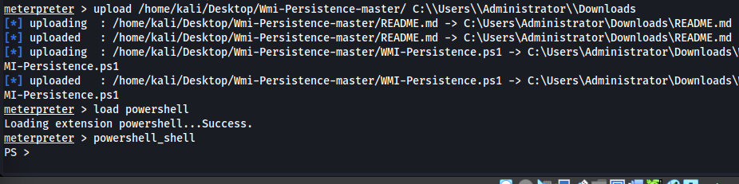

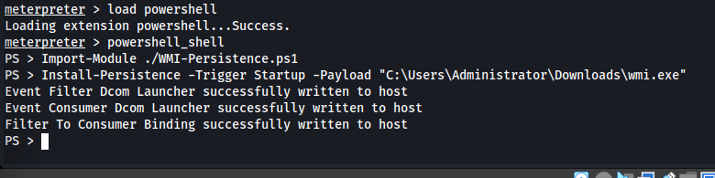

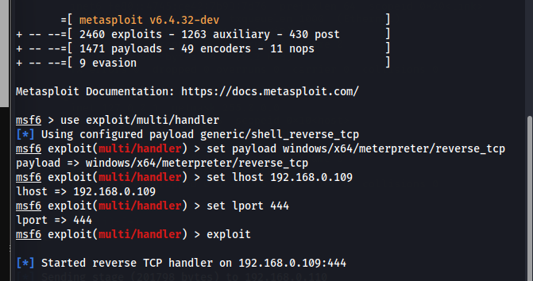

**Covert Channels using Covert_TCP:**

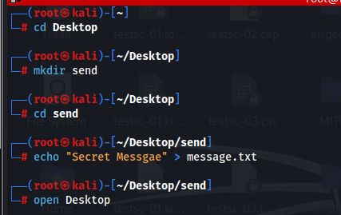

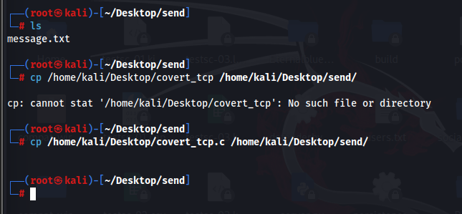

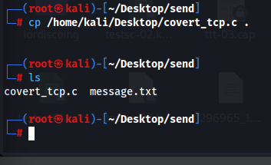

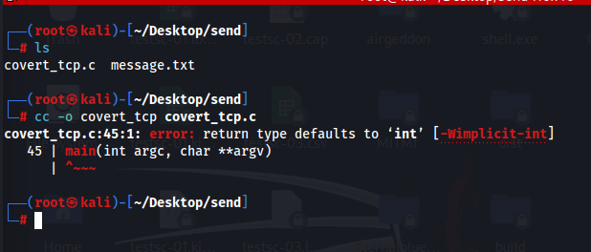

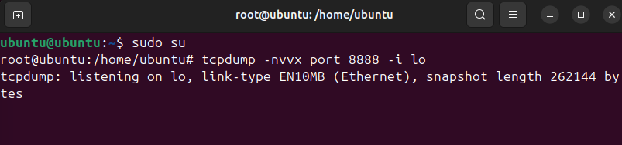

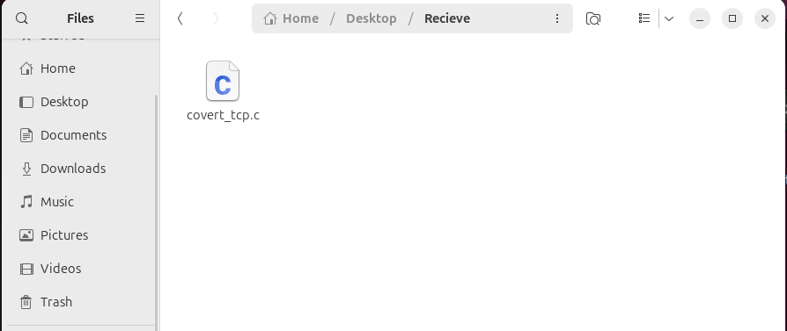

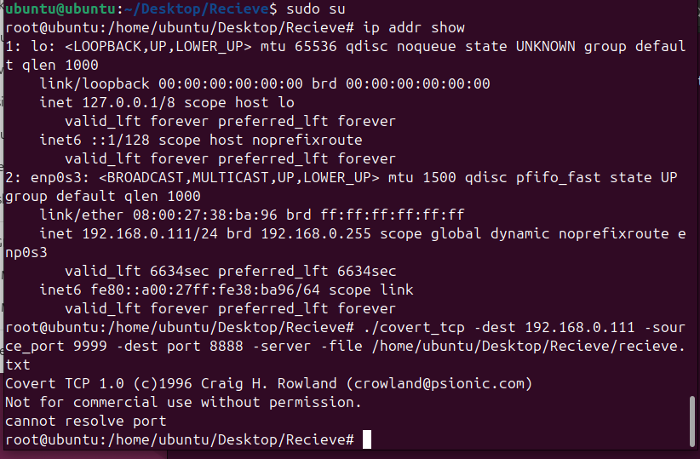

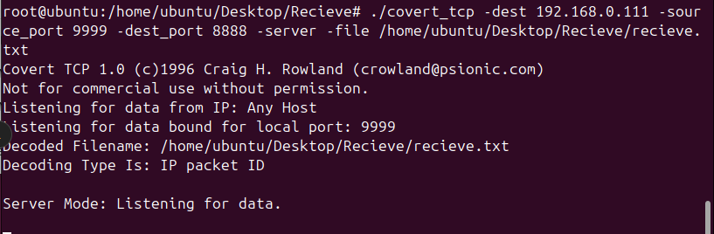

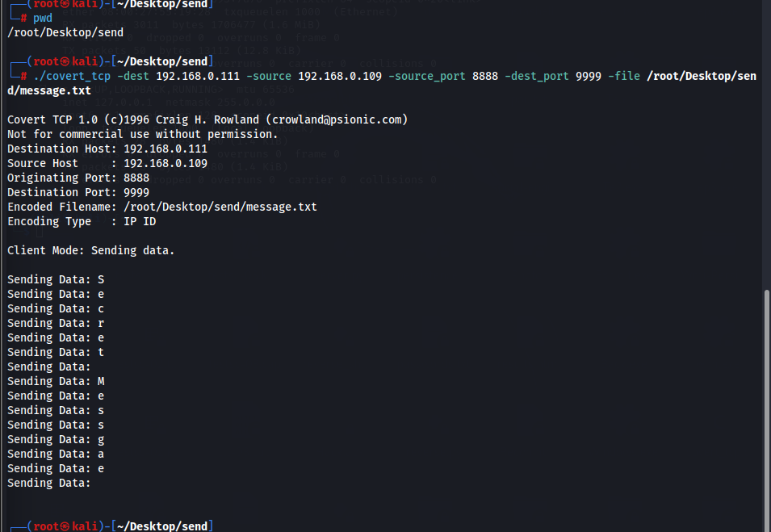

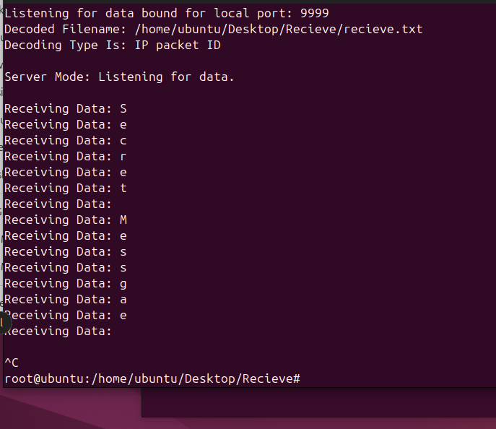

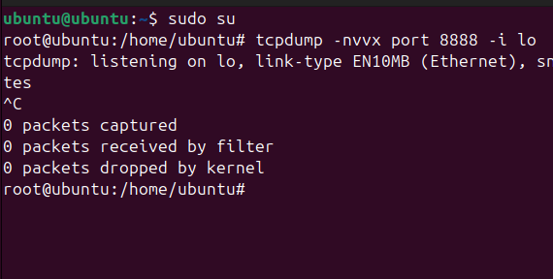

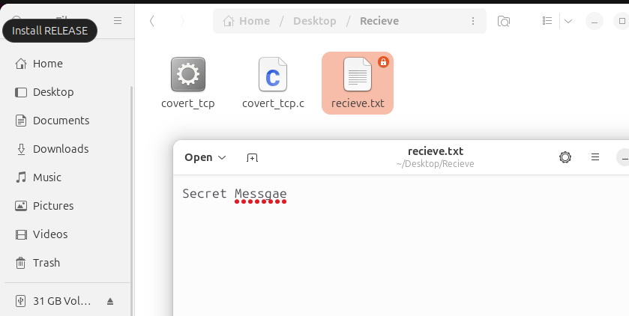

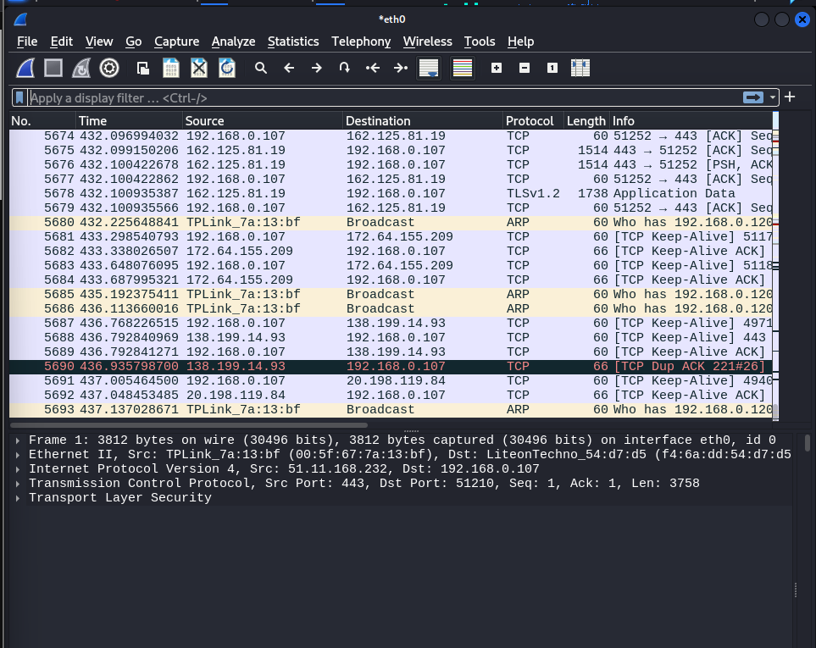

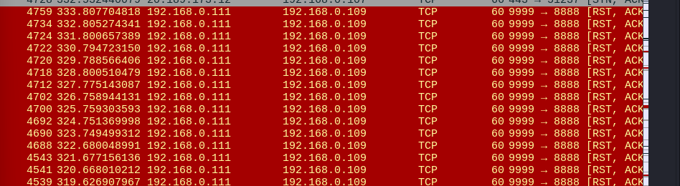

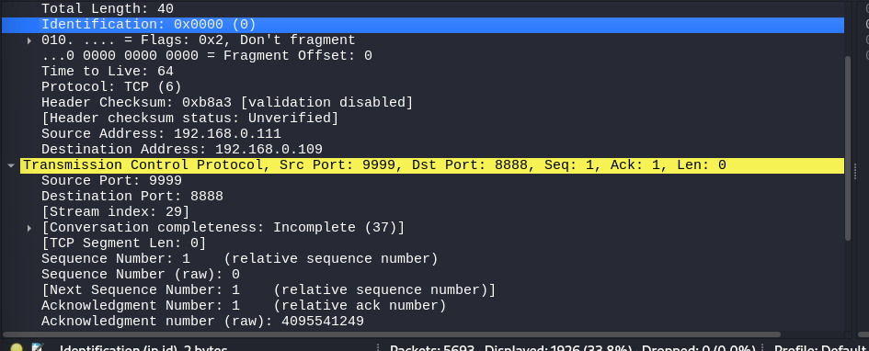

**View, Enable, and Clear Audit Policies using Auditpol:**

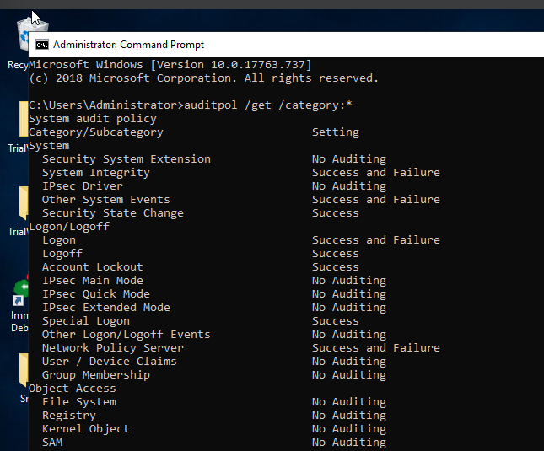

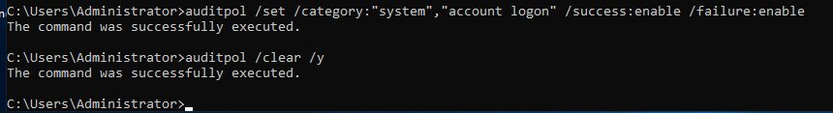

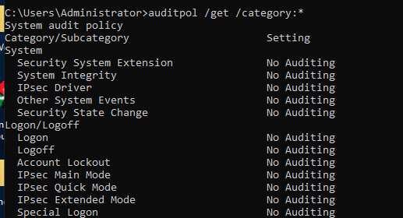

**Clear Windows Machine Logs using Various Utilities:**

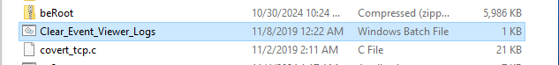

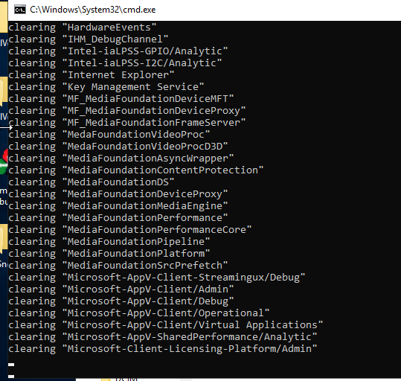

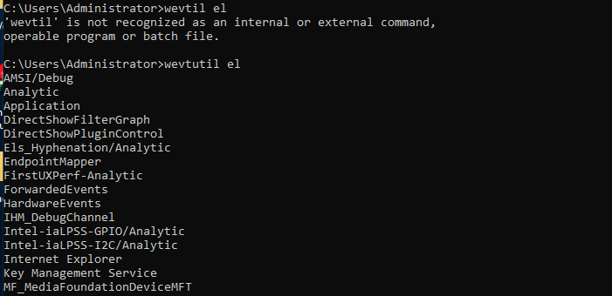

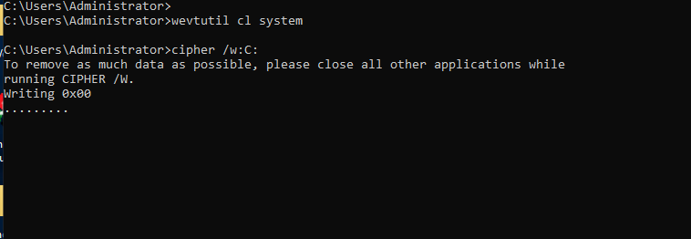

**Clear Linux Machine Logs using the BASH Shell:**

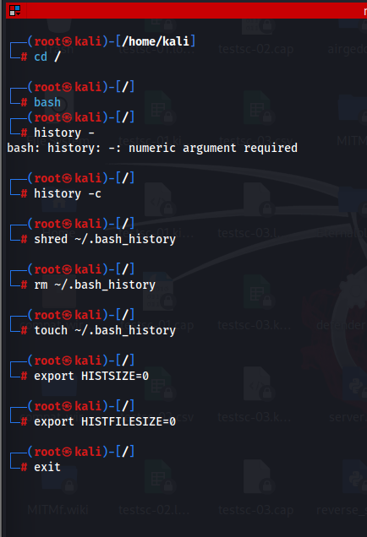

**Hiding Artifacts in Windows and Linux Machines:**

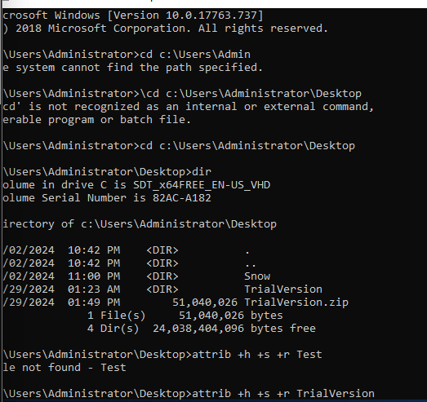

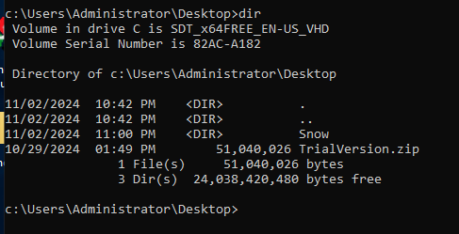

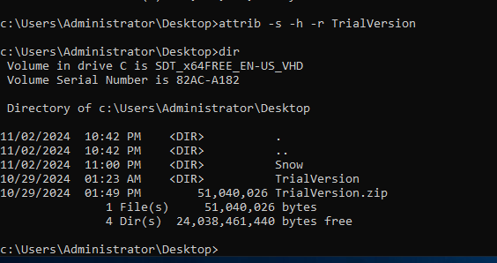

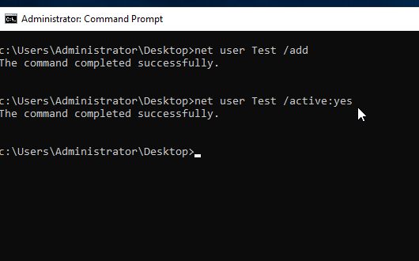

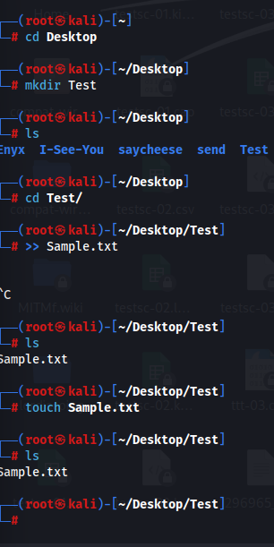

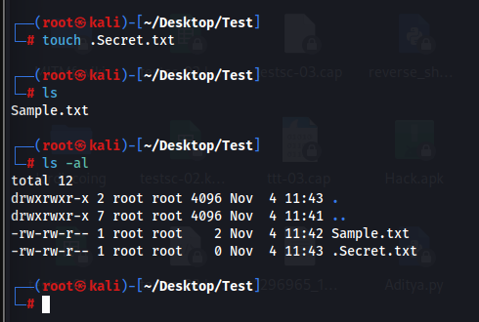

**Clear Windows Machine Logs using CCleaner:**

